Empowered lives.
Resilient nations.
2014
Annual Review
UNDP Innovation Facility
Version
2.9
. See undp.org/innovation for updates.

Contents
Foreword……………………,,… ……3 Executive Summary……….…..……4
Why Innovation for
Development?…………………. ……7
UNDP’s Emerging Innovation
Framework……………………………8
The Innovation Facility………. ……9
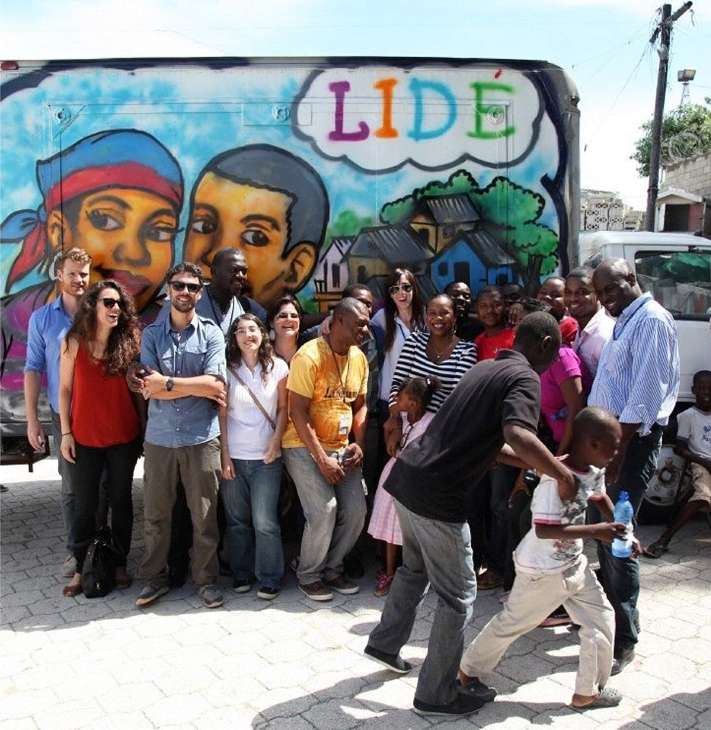
Summary of Activities……..… ….10 Innovation Principles………… ….11
Launch of UNDP Haiti’s LIDE project during the SHIFT Week of
Innovation Action in September 2014. The project includes a
roving innovation lab providing a space for unemployed
youth to innovate and kick-start their micro-enterprises.
Innovation Facility Initiatives. ….13
Social Innovation Expert
Roster…………………………… ….23
Partners…………………………. ….24
Annex 1 – Portfolio Snapshot by Region…………………….… ….25
Annex 2 - Initiatives Funded
by UNDP’s Innovation Facility………………..…………. ….32

Foreword
UNDP established an Innovation Team with dedicated staff at HQ in New York and all five Regional Hubs. The Team is within the Development Impact Group of the Bureau for Programme and Policy Support. Learn more about our work at undp.org/innovation and connect to a larger network of experts on Teamworks.
Follow @UNDP_innovation and join the #inno4dev conversation.
Have questions? Reach out to us at innovator.support@undp.org.
We first met the UNDP Innovation for Development team in our downtown Cairo hub. They had made the effort to come to us, not always a common trait in teams from very large organisations — especially ones that are aware of how bad Cairo traffic can be! It was refreshing to meet a team (of women, including Egyptians) that was as focused on innovation and impact as we are.
This wasn’t a team trying to tick off indicators handed down by higher-ups, but a team driven to use innovation as a tool towards empowerment and change.
One of the first things I noticed was that they listened.
They hadn’t come to us with an agenda or yet another “innovation” toolkit and all the answers - instead they were interested in participating, in co-creating, in seeing how their resources and our partnership could achieve the change we both desired. Together we managed to run four fantastic (and extremely fun) events: “Spot the Future”, “Make the Future”, “Gamification for Development” and “Build a 3D printer”. What surprised us was that they had the same vision – these were not events that should be run in silos, but opportunities to create local teams of practitioners - opportunities to exchange knowledge and build local content and capacity. Even more surprising was how the Innovation for Development team functioned: they were light, agile, flexible – yet connected to a very large organisation.
At icecairo we’re used to working with international aid and large private and public sector organisations, many of which sport the same traits: slow, bureaucratic, and are often a bottle neck. We believe that many teams connected to similarly large organisations can learn a lot from the frictionless efficacy with which the UNDP Innovation Team functions. They reverse current trends by enabling and leveraging existing structures instead of trying to replicate them – empowering grassroots organisations and achieving far more impact than by going it alone. These are approaches we would like to see in many of the other actors in Egypt’s innovation and entrepreneurship ecosystem.
Adam Molyneux-Berry Co-founder icecairo, Egypt - one of UNDP’s new partners.
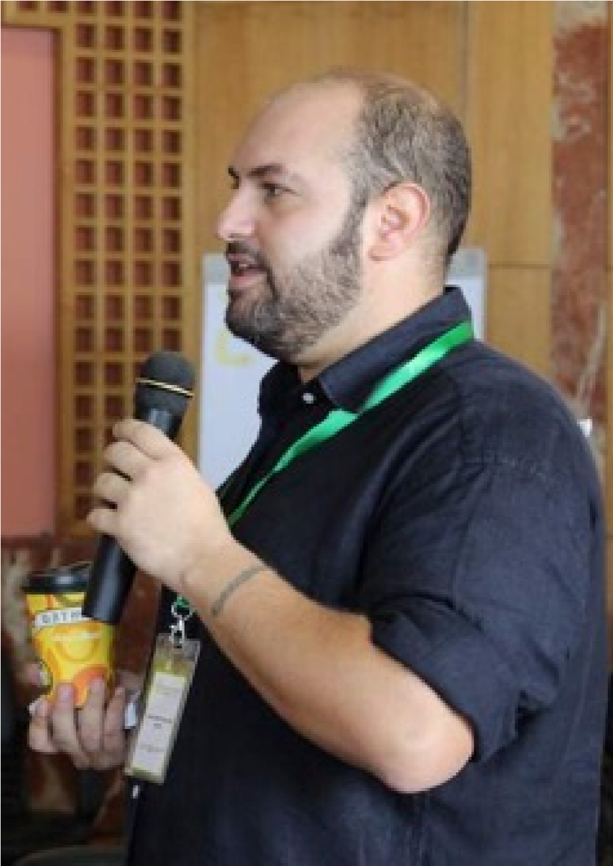

The innovation facility has supported 49 initiatives across 54 countries:
15 of these are Least Developed Countries (LDCs)
8 are Small Island Developing States (SIDS)
16 in crisis affected and peacebuilding contexts, including 4 of 6 countries on the agenda of the UN Peacebuilding Commission.
In 2014 UNDP launched the Innovation Facility to support innovation to address development challenges. The Innovation Facility was made possible with the generous contribution of the Government of Denmark and co-investments from UNDP’s core resources. The Innovation Facility is a funding mechanism managed by a small team of innovation experts at UNDP based in Addis Ababa, Amman, Bangkok, Istanbul, New York and Panama.
This review lays out why innovation is becoming increasingly important for international development and UNDP. It describes our approach to innovation as well as spotlights the initiatives funded by the Innovation Facility in 2014. UNDP has invested in new ways of doing business and over the past three years began strategically exploring innovation under the motto “innovation happens in practice.” Through the Innovation Facility we strive to accelerate this approach by putting innovation in development solutions on a new trajectory.
Innovation for development promotes calculated risktaking and heavily focuses on learning. The emphasis on 'working on out loud' - on sharing insights and asking for feedback while designing and implementing - is an important element of UNDP’s approach to innovation.
The Innovation Facility provided innovation champions in UNDP Country Offices with the necessary means and corporate backing to test novel concepts and solutions to persisting development challenges, across 49 initiatives in 54 countries. Over 60% of the countries are developing or crisis-affected countries. In 2014, the Innovation Facility supported initiatives in:
8 Small Island Developing States (SIDS) – Haiti, Maldives, Mauritius, Papua New Guinea, São Tomé and Principe, Seychelles, St. Kitts and Nevis and Tonga;
20 countries characterised as LDCs or LLDCs;
16 crisis-affected or peace-building situations, including 4 of 6 countries on the agenda of the UN Peace-building Commission and 13 situations on the agenda of the UN Security Council for 2014.
The initiatives funded by the Innovation Facility focused on three areas:
Supporting citizen engagement through the development of responsive feedback mechanisms and pathways;
Providing strategic foresight services to governments to strengthen the flexibility of national planning instruments;
Establishing spaces to co-design solutions to social problems through innovation labs and camps for citizens, particularly the youth.
Grants from the Innovation Facility are a form of catalytic seed capital and so far have been deliberately small - between US$40,000 and US$160,000 per initiative. Grants were provided to a mix of initiatives linked to ongoing projects, programmes and new endeavours.
Highlights of key results in 2014 are:
The uptake of strategic foresight as planning and dialogue instruments by the Governments of Rwanda and Tonga.
The launch of a roving innovation lab in Haiti that provided young people from remote areas with support to create business plans. The outreach on social media of the initiative caught the attention of the Prime Minister’s office which is interested in scaling up the concept if it proves successful and cost-effective.
Continued.
In development, innovations need to add value to the end-user. They need to result in and trigger tangible changes for communities and countries.
In Bangladesh, Côte d’Ivoire, El Salvador, the Maldives, and Papa New Guinea, citizens’ feedback is collected through mobile and online platforms, offering their respective governments further policy insights into issues important to local communities, such as traffic, infrastructure damage and corruption.
In China, UNDP partnered with the private sector to develop a business model for e-waste recycling. Based on the analysis of big data, an app for customers was cocreated with end-users. By the end of 2014 more than 100,000 people requested recycling services through the prototyped version of the app.
To support innovation champions and provide colleagues and partners with tools, UNDP, together with Nesta, a UKbased innovation fund, and other partners, created the Development Impact and You toolkit which offers a variety of tools to assist development practitioners in inventing, adopting and adapting ideas that can deliver better results.
In Moldova, UNDP facilitated the re-design of police stations, embracing a human-centred approach that facilitated an open dialogue between citizens and the government.
In Egypt, UNDP established a social innovation lab that provides partners, especially young people, with the space to generate ideas and prototypes.It serves as an incubator to test solutions on topics ranging from social justice,
sexual harassment and people with disabilities to smart
cities.
In total, the Innovation Facility funded 49 initiatives with 38 implemented by Country Offices and 11 implemented globally and regionally. This includes the global advocacy initiative for social innovation - SHIFT Week of Innovation Action - hosted by more than 20 Country Offices in September 2014.
The delivery rate is 96.6% of the total budget of US$3.2 million, with US$2.7 million contributed by the Government of Denmark and US$500,000 co-invested from UNDP’s
Global Programme.
As most initiatives kicked-off in the middle of 2014, the full impact of the work will be assessed in 2015. UNDP is committed to closely monitoring the results of these early endeavours, with the intent to bring successful approaches to scale. A key tenet of innovation is that new ideas do not suffice. In the development field, innovations need to add value to the end-user. They need to result in and trigger tangible changes for communities and countries.
To advance the discourse on innovation for development, members of UNDP’s Innovation Facility supported and participated in four international conferences in 2014.
At AidEx in Brussels, Jens Wandel (UN Assistant-SecretaryGeneral, Director of UNDP’s Bureau of Management and member of the Innovation Board) gave the Keynote Speech.
The Data Innovation for Policy Maker Conference in Indonesia was a collaboration with UN Global Pulse and Indonesia’s Ministry of National Development Planning to advance the field of big data analysis for development as well as privacy and security concerns. This was instrumental to open a number of doors with private sector partners.
In October 2014, UNDP together with USAID, UN-Habitat and UN Global Pulse hosted the Asia Urban Futures Workshop to bring together the science and technology sectors, development community and progressive city planners to discuss the rising challenges and opportunities facing Asia as the result of rapid urbanisation and climate change.
At the end of October 2014, UNDP held the Asia-Pacific Regional Innovation Summit which convened over 90 development practitioners and leading innovators from 30 countries, donor agencies, governments, both partner and private organisations, and media partners. The summit took stock of and shared progress of initiatives supported by the Innovation Facility, while learning from successfully scaled up projects. It also provided exposure to new ideas and innovation concepts, and explored new opportunities for cross-sector collaboration
Continued.
UNDP supported the following international conferences in 2014:
Asia-Pacific Regional Innovation Summit
Asia Urban Futures Workshop
Data Innovation for Policy Makers
Innovation entails calculated risk-taking. Learning and adapting are key elements of our approach to innovation. Lessons from 2014 include:
A greater emphasis on scaling is needed. This applies to innovation initiatives proposed by UNDP Country Offices and units. The Innovation Facility will work with Country Office teams to ensure the design of new initiatives incorporates clear scaling pathways from inception. In 2014, UNDP Asia-Pacific invested in a dedicated Scaling-Up Fund which is being reviewed in 2015. The insights of this model will serve as good practices for UNDP globally.
Dedicated investments in scaling. While the inception of new ideas and funds for rapid prototyping and testing is an important elements in the field of innovation, we see that continuous (risk) investment in scaling is not yet sufficiently emphasised.
A stronger focus on co-designing with rural, conflict-affected or vulnerable populations in hardto-reach areas. In 2014 a number of initiatives were not designed to engage with the ‘hardest to reach’ users but with urban and comparatively welleducated segments of the population.
An investment in changing rules and procedures to mainstream new processes. Several initiatives in 2014 embraced methods and processes that are not yet harmonised with UNDP’s Policies and Operations Manual. For example, crowd-sourced challenges and ‘Open Innovation’ initiatives are not within the organisation's regulatory framework. To mainstream this practice a new policy was drafted and is being reviewed at UNDP for adoption in 2015.
Only together with entrepreneurial partners and people affected by development challenges can we find the next generation of catalytic solutions to reach the targets of the Post-2015 agenda.
This report is also an invitation to work with us! Reach out and collaborate with us via innovator.support@undp.org or @UNDP_innovation and join the #inno4dev conversation on Twitter.

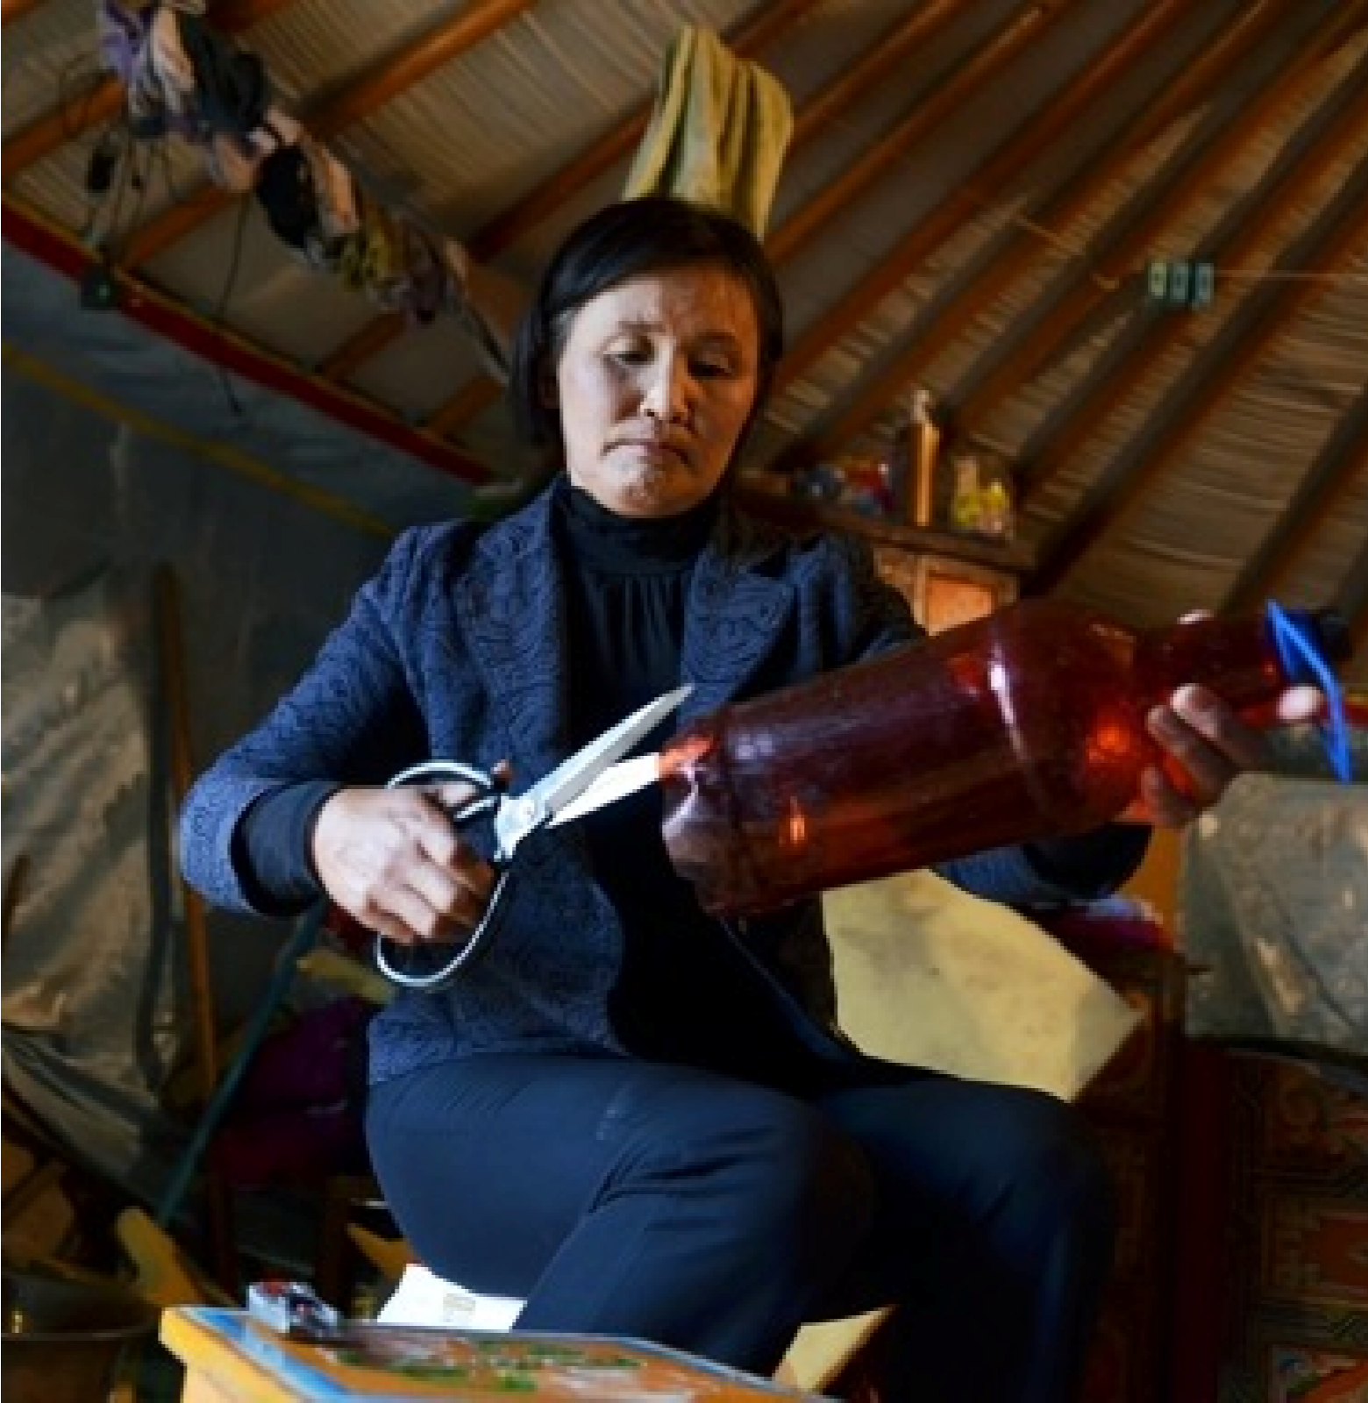
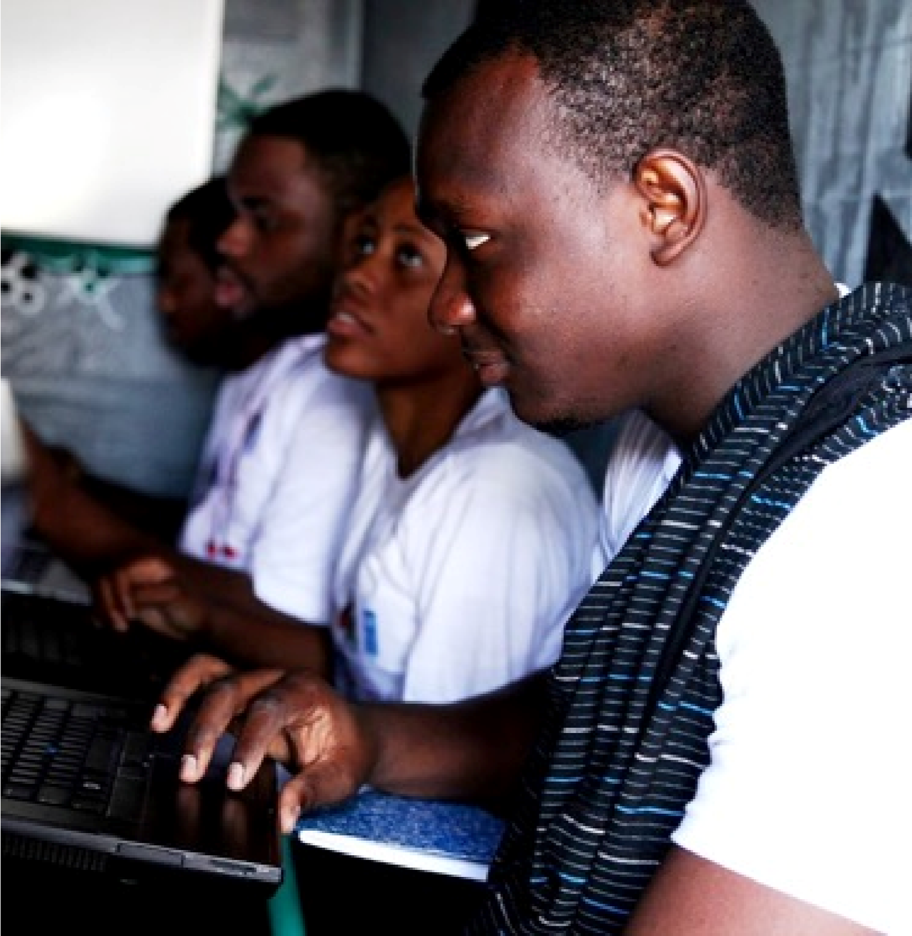
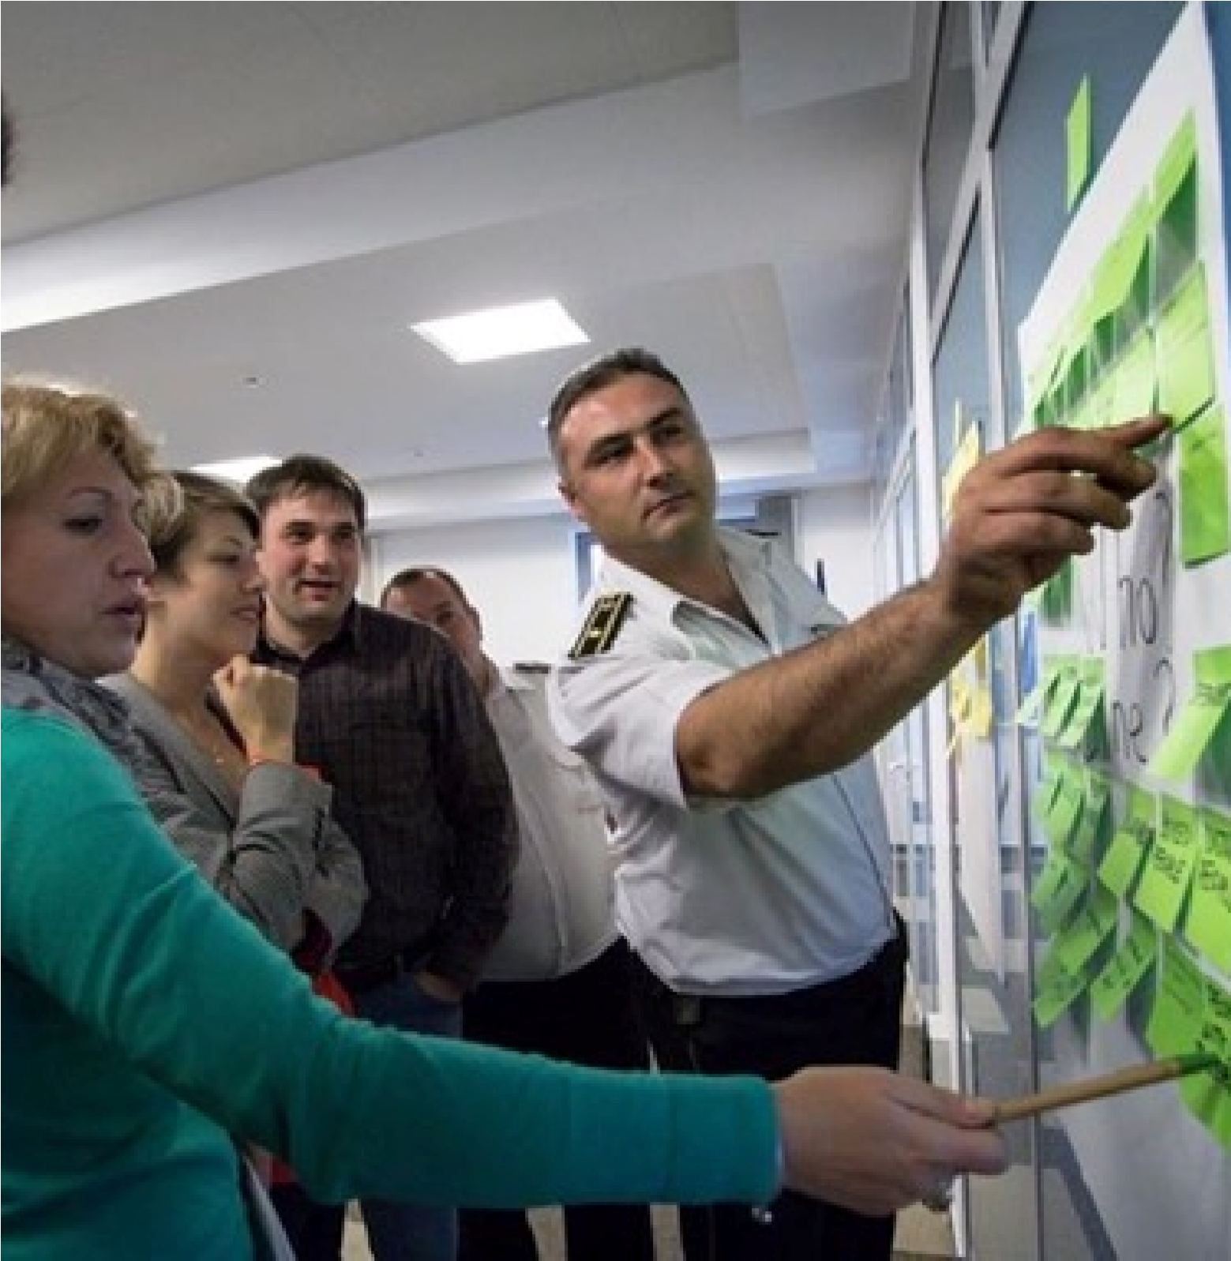
Why Innovation
for Development
?
In 2014, the UNDP Innovation Facility
supported initiatives in (left to right)
Mongolia, Haiti and Moldova looking
at the issues of waste management,
youth entrepreneurship and public
service provision, respectively
.
Development challenges are increasingly complex.
They are inter-connected and the pace of change,
partially accelerated by information technologies,
is unprecedented. Development organisations
work in environments characterised by volatility,
uncertainty and unpredictability. Traditional
planning instruments are in many cases not able
to respond to changes in the development
environment and programming arrangements of
development actors are often not agile enough to
adapt adequately to new developments.

As these changes a
ff
ect all countries across the
globe, it becomes ever more important for UNDP,
the UN System and development actors to
respond to the changing landscape of
development challenges with agile and flexible
solutions, representing a shift away from business
as usual. Over the past three years UNDP invested
in strategically exploring innovation under the
motto “innovation happens in practice”.

UNDP’s Emerging
Innovation

Framework
“Innovation is not an end in itself. It is about using the most up-to-date concepts and means available to get the best development results.”

Helen Clark UNDP Administrator
In 2013 UNDP made a deliberate and concerted effort to refine its approach to "innovation for development." A conceptual framework to guide our work has emerged, informed by practical collaborations with like-minded development practitioners and innovators — including Innovation Funds, Think Tanks, NGOs, as well as input and guidance of innovation champions across all levels of the organisation. The core principles underpinning this framework focus on the identification of bottlenecks, rapid testing of ideas through prototypes and pilots, scaling up what is proven to work, and ”working out loud" at all times to benefit from the feedback of end-users, partners and stakeholders to shape action and impact.
Overall, UNDP’s innovation work focuses on 'process' innovation, i.e. transforming UNDP’s programming and introducing novel ways of doing business to the development landscape, together with partners. Technology is an accelerator of innovation but it is not the only driver of our work. Consulting stakeholders when designing a development initiative is not a new concept as it has long been a development practice. However, placing the people affected by development challenges – the end-users - at the heart of the process, engaging them in identifying the challenges and in co-creating solutions, is indeed new and our main driver.
Over the past few years innovation initiatives across the globe have tested novel concepts such as humancentred design to improve public service delivery; strategic foresight to enhance the flexibility of planning processes; innovation labs to incubate and field test user-driven innovations; and behavioural insights and user-led innovations to create feedback loops between citizens and the government.
Innovation is also embedded in UNDP’s Strategic Plan for 2014 to 2017 with a dedicated deliverable on innovation for development focused on enabling development solutions, partners and other collaborative arrangements.This is a clear signal of UNDP’s commitment to invest resources in innovation and to support innovation champions who challenge business as usual.
To drive this agenda, UNDP established an Innovation Team with dedicated staff at HQ in New York and all five Regional Hubs. There is also a vibrant Community of Practice on innovation for development. Established in 2012, the network brings together more than 500 innovation champions from Country Offices, Regional Hubs and HQ as well as UN agencies, innovation funds and academia to exchange experiences and lessons. A monthly newsletter provides updates on UNDP’s work in innovation for development .
Identify
bottlenecks
Find and
reflect on
solutions
Prototype

& pilot
solutions
Scale
Work out loud
UNDP’s Emerging Innovation Framework

The Innovation Facility
In June 2014 UNDP and the Government of Denmark signed a cost-sharing agreement establishing the UNDP Innovation Facility, a global mechanism to support innovation for development – effectively the “home” of UNDP’s drive to systematically innovate. The strategy for its implementation is contained in the Innovation Facility Project Document.
The Facility is designed to offer the organisation and its collaborators across the globe with technical and financial support to explore new approaches to increasingly complex development challenges. This support includes:
Seed funding for - research and development; scanning and finding breakthroughs, including building and testing prototypes of novel interventions;
Platforms and incentives for sharing and communicating experiences throughout the innovation process, and learning across countries and regions;
Resources to support innovation, such as a community of innovation colleagues, a network of external experts in a number of high-demand specialised fields, and a set of toolkits for staff learning and development.
Grants from the Innovation Facility are a form of catalytic seed capital and so far have been deliberately small - between US$40,000 and US$160,000 per initiative. The grants are focused on initiatives linked to ongoing projects and programmes that display the potential for scaling-up or adaptation. UNDP has also invested in the creation of a Social Innovation Expert Roster to support offices in their innovative endeavours, which will be launched in 2015.
The Innovation Facility is managed by the Innovation
Team within the Development Impact Group (DIG) in the Bureau for Programme and Policy Support (BPPS). The team includes HQ-based staff in New York and Innovation Specialists in each of the five Regional Hubs.
The DIG staff in the Regional Hubs work in Portfolio
Management Teams (as detailed in the Innovation Facility Modus Operandi) with at least one staff from the respective Regional Bureau. The Regional Portfolio Teams are responsible for bundles of initiatives at the regional level. This arrangement allows for decentralised management of Innovation Facility funds, empowers decision-making at the portfolio level, and provides an effective way of linking regional and thematic initiatives to other innovation initiatives taking place around the organisation. The Regional Portfolio Teams are responsible for soliciting proposals from Country Offices and generating Regional proposals. They also spearhead validating and vetting proposals, as well as strengthening them as needed through advisory services; managing delivery of funds allocated; and frequently reporting on progress by working out loud throughout the entire process. The Regional Portfolio Management Teams, the point of contact for the Country Offices, are primarily responsible for management of regional initiatives and are the key players to introduce novel ways of working at the country-level.
The Innovation Facility Board provides strategic direction and approves key decisions including the allocation of available funds to each region and global initiatives. In 2014, the members of the Innovation Board were:
Ms. Dafina Gercheva, Deputy Director, Bureau of
Management
Mr. Magdy Mzartinez-Soliman, Assistant SecretaryGeneral; Director, Bureau for Programme and Policy Support
Mr. Jens Wandel, Assistant Secretary-General; Director, Bureau of Management
Mr. Haoliang Xu, Assistant Secretary-General; Director,
Regional Bureau Asia-Pacific
The modus operandi of the Innovation Facility as well as the minutes of the Board meetings are publicly available at unteamworks.org/innovation.

Summary of Activities
U
See Annex 1 for details of Allocations and Expenditure by Region.
See Annex 2 for the full list of initiatives.
In 2014, the initiatives funded by the Innovation Facility focused on three areas: | In spite of the short four month implementation window, the delivery rate is 96.6% of the total budget of US$3.2 million, with US$2.7 million contributed by the
Supporting citizen engagement through the
development of responsive feedback mechanisms and pathways. | Government of Denmark and US$500,000 co-invested from UNDP’s Global Programme.  In June 2014, the Innovation Facility Board agreed on
to strengthen the flexibility of national planning instruments. | the allocation per region and global initiatives, reflected in the graph below. This division of allocations allows flexibility for Regional Portfolio Teams to fund
Providing strategic foresight services to governments
problems through innovation labs and camps for citizens, particularly youth.  In total, the Innovation Facility funded 49 initiatives in 54 countries in 2014, with 38 implemented by Country Offices and 11 implemented globally and regionally. This includes the global advocacy initiative for social innovation - SHIFT Week of Innovation Action - hosted by more than 20 Country Offices, bringing together over 1,800 participants in September 2014. | provides the Innovation Facility with the option to invest in strategically relevant initiatives that encompass regions and to support internally focused innovation initiatives.  The snapshot below provides an aggregated summary of the allocations and expenditures.
Establishing spaces to co-design solutions to social initiatives aligned to regional priority areas. It also
UNDP Innovation Facility: Expenditure Snapshot by Region
Africa
Arab States
Asia and Pacific
Europe and CIS
Latin America and Caribbean
Global (UNDP funded)
Global (Denmark funded)
TOTAL
US$0
US$1,000,000
US$2,000,000
US$3,000,000
Allocated Expenditure
Under Expenditure
Over Expenditure
Africa
Arab States
Asia and Pacific
Europe and CIS
Latin America and Caribbean
Global (UNDP funded)
Global (Denmark funded)
TOTAL

Innovation Principles
These innovation principles are supported by: UNDP,
UNICEF, USAID, Gates Foundation, EOSG Global Pulse, WFP, WHO, HRP, OCHA, SIDA, IKEA Foundation, UN Foundation, and UNHCR.
1. Design with the User
Develop context appropriate solutions informed by user needs.
Include all user groups in planning, development, implementation and assessment.
Develop projects in an incremental and iterative manner.
Design solutions that learn from and enhance existing workflows and plan for organisational adaptation.
Ensure solutions are sensitive to, and useful for, the most marginalised populations: women, children, those with disabilities, and those affected by conflict and disaster.

2. Understand the Existing Ecosystem
Participate in networks and communities of likeminded practitioners.
Align to existing technological, legal, and regulatory policies.
3. Design for Scale
Design for scale from the start, and assess and mitigate dependencies that might limit ability to scale.
Employ a “systems” approach to design, considering implications of design beyond an immediate project.
Be replicable and customisable in other countries and contexts.
Demonstrate impact before scaling a solution.
Analyse all technology choices through the lens of national and regional scale.
Factor in partnerships from the beginning and start early negotiations.

4. Build for Sustainability
Plan for sustainability from the start, including planning for long-term financial health i.e., assessing total cost of ownership.
Utilise and invest in local communities and developers by default and help catalyse their growth.
Engage with local governments to ensure integration into national strategy and identify high-level government advocates.

5. Be Data Driven
Design projects so that impact can be measured at discrete milestones with a focus on outcomes rather than outputs.
Evaluate innovative solutions and areas where there are gaps in data and evidence.
Use real-time information to monitor and inform management decisions at all levels.
When possible, leverage data as a by-product of user actions and transactions for assessments.

6. Use Open Standards, Open Data, Open Source, and Open Innovation
Adopt and expand existing open standards.
Open data and functionalities and expose them in documented APIs (Application Programming Interfaces) where use by a larger community is possible.
Invest in software as a public good.
Develop software to be open source by default with the code made available in public repositories and supported through developer communities.

Innovation Principles
- Reuse and Improve 9. Be Collaborative
Continued.Use, modify and extend existing tools, platforms, and frameworks when possible. Engage diverse expertise across disciplines and industries at all stages.
Develop in modular ways favouring approaches that Work across sector silos to create coordinated and are interoperable over those that are monolithic by more holistic approaches.
design. Document work, results, processes and best practices
- Do No Harm and share them widely.
Assess and mitigate risks to the security of users and Publish materials under a Creative Commons license
their data. by default, with strong rationale if another licensing
Consider the context and needs for privacy of approach is taken. personally identifiable information when designing solutions and mitigate accordingly.
Ensure equity and fairness in co-creation, and protect the best interests of the end end-users.

Global initiatives in 2014 focused on key areas such as big data analysis, crowdsourcing the future development agenda and urban innovation.
See Annex 2 for the full list of
In 2014, the Innovation Facility funded nine initiatives with a global or inter-regional scope, including the global campaign — SHIFT Week of Innovation Action. These global initiatives problem solve through strategic foresight, big data analysis, crowdsourcing the future development agenda and urban innovation. Below is a selection of global initiatives.
Foresight for Adaptive Leadership, Inclusive Futures and Resilience
In 2014, the UNDP Global Centre for Public Service
Excellence organised foresight workshops in Tonga and Rwanda to introduce foresight techniques to the government and community to strengthen their resilience and adaptability of visions, strategies, policies and implementation tactics. This initiative was linked to foresight initiatives in Sudan and a regional research and development event in Istanbul in June 2014.
In Tonga, where the focus was on issues of climate change, the over 100 participants representing different societal sectors explored alternative futures via a foresight exercises. The results were discussed in a meeting with the Cabinet and all Heads of Departments. After the event in Tonga, there was a formal decision by the government to enhance planning and implementation strategies with foresight techniques; presentations on foresight for resilience at the 2014 SIDS conference by the Tongan Prime Minister and
UNDP Administrator; and the adoption of the ForesightXplorer exercise in several community consultations. Rwanda aimed to strengthen the anticipatory and adaptive capacity of the government to mitigate risks, maximise opportunities, enhance "whole-of-governance" approaches and speed up delivery of development results. Following the event, the Rwanda Governance Board is preparing to implement public planning enhanced by foresight at the national, regional and local level. Further, the Rwandan and the Strategy and Policy Unit is introducing a
national Innovation Fund to stimulate cross-sectoral collaboration.
Highlights of results: The governments of Rwanda and Tonga adopting strategic foresight techniques in their national planning instruments.
Data Innovation for Policy Makers
Data innovation is talked about in policy circles but there’s still unfortunately a limited body of practice to substantiate claims of its positive impact or an in-depth understanding of the potential negative consequences. The purpose of this activity was to accelerate the process of moving from theory to practice in data innovation; facilitate the creation of a sub-regional ecosystem of data innovation practitioners; take stock of existing data innovation practice; and raise awareness among policy makers of the gap between theory and practice. Through UN Global Pulse, this initiative consisted of workshops with data innovators and policy makers in Indonesia, fundraising and partnerships, organising an international conference on data innovation for policy makers, and the launch of data innovation mini-grants to stimulate the development of a body of practice. In collaboration with Indonesia’s Ministry of National Development Planning and the local data innovation community, the conference was instrumental in opening up a number of conversations with private sector partners and potential donors. As a resourceful partner with expertise in data innovation, UNDP showcased its work on disaster response and fire monitoring.
Highlights of results: Partnership with Indonesia’s Ministry of National Development Planning established and mini-grant competition with funding from partners launched.

SHIFT Week of Innovation Action
Continued. The SHIFT – Week of Innovation Action was the central campaign launched by the Innovation Facility to further promote innovation within UNDP, to accelerate ongoing initiatives, positioning UNDP as a partner for innovation on the national level in 21 participating countries.
SHIFT was a series of parallel events designed to shift ideas, shift the way UNDP works, and shift people across the globe to learn from each other on innovative approaches to development and drive innovation between regions, countries and sectors. During the week of 22 September 2014, 21 UNDP Country Offices hosted events with national partners, colleagues and external experts on a variety of topics such as gamification, crowdfunding, design thinking, hackathons, storytelling and open data, among others.
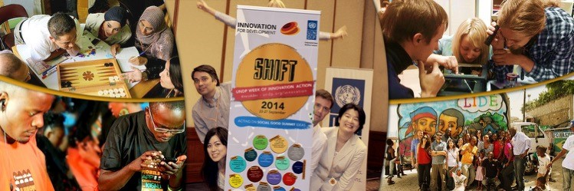
These events brought together over 1,800 participants to share, learn and exchange ideas on innovation for development. They were joined by experts, design thinkers, students, innovation gurus, hackers, endusers and general social innovation enthusiasts. These discussions and take-aways were shared both in realtime via SHIFT.tv as well as in blogs, videos and multimedia journals after the events. These events amplified cross-regional knowledge exchange throughout UNDP. For example, thanks to the crowdfunding event in Jordan, colleagues at UNDP Haiti are launching a crowdfunding campaign for their roving innovation lab initiative.
The SHIFT events were either accelerators of ongoing initiatives or launched new endeavours. For example, UNDP Kosovo* worked with a municipality to make its procurement data over the past 7 years accessible, enhancing public transparency.

The SHIFT – Week of Innovation
Action took place in 21 countries with
1,800 game-changers on crowdfunding, design thinking, hackathons, story telling and open data.
Discussions and events were shared in real-time via SHIFT.tv, on blogs and multimedia journals.
See Annex 2 for the full list of

* Referred to in the context of UN Security Council Resolution 1244 (1999)

Continued.

Africa
9 countries and 2 regional initiatives in Africa use social innovation to tackle local challenges.
See Annex 2 for the full list of

AFRICA
The UNDP Innovation Facility supported nine Country
Office initiatives and two regional initiatives in the Africa Region. A number of the projects focused on improving organisational and programme effectiveness by employing improved monitoring and evaluation strategies, as well as narrative and data capture. Other initiatives aimed at taking on a variety of issues related to disaster preparedness, renewable energy, policing services, employment and ICTs. These projects have a strong emphasis on involving a diverse set of actors throughout the process, trying out new partnerships with innovation hubs, youth groups, private sector and civil society, all the while linking them with traditional government partners.
The Innovation Facility received more than 40 proposals from Africa as a result of the regional call for proposals which were reviewed and scored by the Regional Portfolio Team and the HQ-based team. The content and quality of a significant number of proposals underlined the necessity to further invest in capacity building the Africa region on UNDP’s approach to innovation and in repositioning the offers of the Innovation Facility. This is partially due to the national contexts of many African countries, particularly least developed countries, in which the choice of potential partners in the social innovation field is limited and bandwidth problems as well as significant digital divides between urban and rural areas pose challenges to embrace technology as an accelerator for innovation.
The results achieved in 2014 and the ongoing activities of the initiatives in Burundi, Côte d’Ivoire, Rwanda, São Tomé and Zimbabwe are key examples to demonstrate the added value of innovation approaches to achieving development results. Zimbabwe, in particular, demonstrated the potential of creating partnerships with government institutions and co-designing innovation spaces for entrepreneurs with local actors from the small social innovation community. Below are three brief descriptions of innovation initiatives in Africa.

Côte d’Ivoire
Placing the Discussion of Gender Sensitive Policing on the Parliamentarian and Public Agenda
The conflict in Côte d’Ivoire has led to a lack of trust, and even fear, of the police force by the general population, which negatively impacts the way in which gender sensitive issues are addressed. This project created a dialogue between parliamentarians, police and the population on safety matters for girls and women in Côte d’Ivoire and the role the police could and should play to ensure better security for girls and women. The project also trained the media on how to report on security challenges for girls and women and the role of the police. For the SHIFT Week of Innovation Action, two colleagues from UNDP Côte d’Ivoire attended an event in Rwanda on mobile apps and left with a game-changing takeaway: the development of an easy-to-use SMS polling application would be an effective way for them to capture the voice of the population on gender sensitive police challenges and priorities. The polling app is entering the piloting and testing phase and, if successful, they plan to scale up SMS polling to all regions in addition to using it to undertake a performance ranking of local police stations. The initiative has moreover the potential to be used in the delivery of other public sector services.
Highlights of results: A polling mechanism to source citizens’ feedback on police services related to gender inequalities has been co-developed. Through SMS polling, 1,510 users identified three priority areas among ten for the Parliament and police: rape, domestic violence and circumcision. Processing feedback sourced via an app was agreed on with the police force and government.
Continued.
See Annex 2 for the full list of

São Tomé and Principe
Monitoring Transformative Impact on Development Programmes
Responding to the need to measure the long-term impact of UNDP’s work and development programmes in general, UNDP São Tomé and Principe is using polling methodology to assist in monitoring impact through measuring trends, perceptions and relevance of sustainable development investments. In September, the Country Office held an event for the SHIFT Week of Innovation Action which focused on exploring polling methodologies together with 40 participants from the government, private sector and UNDP. They found that the use of polling tools can monitor investments in development in an independent and transparent way, as well as in a specific space for a long period at a low cost. The information collected will provide important insights from the community, leading to changes or improvements in country programmes at UNDP, better development outcomes and coordination of the UN development system.
Highlights of results: Polling system co-designed with partners. The first prototype has been developed to improve the monitoring and evaluation as well as the facilitation of faster feedback loops with end-users of development solutions.

Zimbabwe
Towards an ICT4D Policy and Practice Platform
UNDP Zimbabwe, together with national partners, is addressing growing youth unemployment by leveraging the creative potential of young entrepreneurs and startups in the IT sector as one of the key drivers of employment creation as well as improved service delivery and economic growth. This initiative aims to support the establishment of a structured and collaborative innovation platform which will serve as an incubation space where stakeholders will jointly identify opportunities and design prototypes for leveraging ICTs to accelerate development. Innovation labs for business incubation and social enterprises have been set up with ten business projects currently being incubated and five social innovation youth projects in the works. In September 2014, UNDP Zimbabwe held an event, during the SHIFT Week of Innovation Action, which brought together 80 representatives from the Government, technology and innovation hubs, youth organisations and the private sector. The event showcased local ICT solutions to address development challenges and discussed how to establish and nurture strategic PPPs for ICT-led development. In November, UNDP supported Harare Startup Weekend which had a set of open challenges for youth in leveraging new technologies.
Highlights of results: Partnerships with the government and private sector resulted in the creation of the very first innovation labs and challenges for techbased development solutions.

Regional Initiative in Africa
Ebola Response
To strengthen the battle against Ebola, UNDP is working with the authorities in Guinea, Liberia and Sierra Leone to coordinate payments for thousands of treatment centre staff, laboratory technicians, contacts tracers and burial teams. The initiative resulted in the development of a mobile payment tool for Ebola health workers in Liberia. The overall objective of the Ebola response is not only to support governments – which handle payrolls – and partners to continue to pay the workers’ salaries and incentives on time, but also to strengthen and develop systems that will expand access to affordable financial services after the medical emergency is over. In Sierra Leone, UNDP technical advisors assisted the government with two nationwide payments in November 2014 of more than 12,000 Ebola response workers. UNDP has since launched a site with information and analysis on the
Continued.

Arab States
With an emphasis on citizen engagement, UNDP and national partners in the Arab States used a variety of approaches to innovate for development — from design thinking and foresighting to gamification. See Annex 2 for the full list of
Liberia Payments Programme for Ebola Workers including baseline information related to payments (such as mapping of the financial architecture), as well as an online hotline to allow Ebola Workers to access information.
Highlights of results: Funding from the Innovation Facility was catalytic in the design of the mobile payment platform for Ebola response workers in Liberia and the provision of timely payments to more than 12,000 Ebola response workers.

ARAB STATES
The Innovation Facility supported three initiatives in the Arab States. Citizen engagement is a major theme connecting these initiatives across the region. The opportunity for innovation for development in the Arab States is being driven by a number of factors - including demographics (especially the youth bulge); the number of countries affected by conflict or political transitions; the increasing demand for social justice, inclusion and equity; and the increasing prevalence of technology. In response, we are seeing UNDP Country Offices in the Arab States explore a variety of new techniques and game changing approaches with their national partners, everything from design thinking and foresighting to gaming for development.

Egypt
Innovation Lab
UNDP Egypt established a social innovation lab that served as the platform for UNDP’s innovation for development activities and will eventually be scaled to be the platform for Egypt’s social innovation work. The lab focuses on applying citizen-centred approaches in designing and implementing development projects within UNDP, exploring and adopting new processes in development practices, and helps strengthen social innovation capacities of government counterparts and local partners. This is a unique niche for UNDP, leveraging the organisation’s role as an advisor to the government and advocate for the people. While creating a bold and invigorated presence for UNDP in Egypt, it provides coherence to a multitude of activities in the social innovation space.
Particularly notable among its activities were social innovation camps, through which the Lab tackled issues like social justice, designs for integrated living for people with disabilities, and smart cities.
Highlight of results: UNDP Egypt held a Social Justice
Innovation Camp with 45 youth for Egypt's National Human Development Report; a ‘Design for integrated living’ workshop with people with disabilities; 'hack4mobile' smart cities event; and a camp on preventing sexual harassment. Promising prototypes generated during the events are currently being developed and tested.

Sudan
Innovation Nucleus in Sudan: #sudan2030
Under the auspices of its newly formed “Innovation Nucleus,” UNDP Sudan is using foresight as a way to develop a truly shared vision of the future: Sudan 2030. The initiative uses foresight to develop more resilient and agile development plans, in tune with a shared vision of the future of Sudan, ensuring greater ownership and the development of a solid theory of change. The kick-off workshop in November 2014 brought together more than 100 participants representing key stakeholder groups including government, youth groups, civil society, academia and international partners. The next step will be regional scenario planning workshops with the results consolidated and vetted through a series of federal workshops. The activities will be accompanied by an online survey where the results will be collaboratively
Continued.

Asia Pacific
16 initiatives in Asia Pacific offer outof-the-box solutions through app creation to crowdsourcing, gamification and human-centred design to prototype and test ideas across a variety of stakeholders. See Annex 2 for the full list of
analysed, establishing linkages between various factors that emerge and "urgent futures" that will inform the scenario building work.
Highlights of results: Strategic foresight trials resulted in exchange mechanisms between civil society and the government that are novel in the current political context. Government partners expressed interest in the update of strategic foresight as a planning tool and dialogue process with civil society.

Sub-Regional Response Facility for the Syria Crisis
Innovation in the Resilience-Based Development Response to the Syria Crisis
The Sub-regional Response Facility (SRF) has launched a series of innovation jams that use design thinking to co-create innovative solutions to problems of the Syrian crisis. The first event held in November 2014 in Amman, Jordan, aimed to generate innovative ideas to improve livelihoods for host communities and refugees through a resilience lens. It brought together UNDP colleagues from Country Offices most affected by this conflict: Egypt, Iraq, Jordan, Lebanon, Syria and Turkey. Participants addressed their country-specific challenges by engaging in a design-thinking process to facilitate and guide out-of-the-box thinking in problem definition, idea generation and planning. Some ideas included rethinking currency to create a mobile minutes bank; creating a community-based online platform for employment; and providing lucrative solutions to solid waste management. The SRF will be working with the Country Offices to support these ideas moving forward as they are co-created, prototyped and tested with end-users.
Highlights of results: The Jam resulted, among other proposals, in a practical concept for a wastemanagement system for Jordan which is being pursued by the Country Office. It also increased the familiarity with social innovation as an approach with each Country Office team generating ideas to consider in 2015.

ASIA PACIFIC
The Innovation Facility supported 16 projects in UNDP Asia-Pacific that offer solutions outside of traditional project cycles. These initiatives cover a variety of thematic areas such as citizen engagement in public policy, gender-based violence, disaster risk reduction, youth unemployment, and operational efficiency. A range of methods were employed from app creation to crowdsourcing, gamification and human-centred design to prototype and test ideas across a variety of different actors. UNDP Asia-Pacific is supporting the scaling up of innovative development interventions through expanding their scope, increasing the use of their model by various development partners, mainstreaming it into policies and strengthening national capacities. The funds from the Innovation Facility were assigned in sync with the allocations from UNDP’s own scaling-up funds. In fall 2014, the Regional Bureau for Asia-Pacific brought together practitioners and managers from Country Offices that received funding from both sources for the UNDP Asia-Pacific Innovation Summit. The event included presentations from innovation experts from the Behavioural Insights Unit (UK), UNICEF’s Innovation Lab in Kosovo, and Futurescaper (UK). It also included an exercise to assess the scaling potential of the innovation initiatives which will inform the next steps and allocation of funding in 2015.
Three brief examples include:

China
E-Waste Disposal and Management App
As electronic products become ever more available for general consumption, the awareness of the need for environment-friendly disposal of toxic elements has been highlighted like never before. UNDP China and
Continued.
See Annex 2 for the full list of
Baidu, China's largest internet service provider, together launched a Big Data Joint Laboratory to pioneer new methods and frameworks for using big data to support development goals. The inaugural product of the Joint lab is an e-waste recycling smartphone application called “Baidu Recycle“, which allows end users to schedule certified collection of their obsolete home appliances for safe disposal and recycling. App version 1.0 has been produced, launched and was used by over 100,000 individuals by December 2014, with total searches for the Baidu Recycle App numbering 50,000 per day. Version 2.0 of the App is currently under development and will boost the collection capacity by expanding the number of disposal companies involved.
Highlights of results: The partnership established with Baidu leverages big data analysis of the recycling value chain. An app and business process has been developed and prototyping is underway.

Maldives
Make My Island!
In Maldives there are tens of thousands of residents across the islands, who share concerns on community issues such as street-lighting or waste-management. However, there are currently few community meetings and very little scope for dialogue between residents and the council. With a high national level of mobile penetration, UNDP Maldives developed “MakeMyIsland!”, with the concept of using mobile crowdsourcing for better delivery of public services by providing a platform where community members can report their issues - through mobile app, text messaging, or the website. A series of prototype tests are being conducted with the support of the local Island Council, community and local NGOs as well as the team’s pro bono technical partner FixMyStreet (UK) — the source of the original inspiration. So far, 24 municipal issues were reported and fixed under the Make My Island website such as street light damages and mismanagement of waste. The testing, however, also confirms the need to link the SMS reporting with the web platform so that all reported data are shared with the public to engage an even greater number of people in community development.
Highlights of results: Citizen feedback mechanisms have been co-designed with partners, including the development and testing of an app. Lessons from the prototype phase, which included hundreds of mobile reports from citizens, have been compiled. The next phase is underway to scale the innovation across the country for enhanced responsive governance.

Papua New Guinea (PNG)
Phones Against Corruption
It is estimated that almost 40% of PNG’s annual budget was lost to corruption and mismanagement in 2013. Most citizens in PNG do not know where and how to denounce corruption and often fear violent retribution. UNDP, in partnership with the PNG and Australian
Governments, launched the initiative ‘Phones Against Corruption’ to offer a safe space via mobile messaging for citizens to report corrupt practices. All reported cases are anonymous and referred to the Department of Finance’s Internal Audit and Compliance Division for further investigation in collaboration with relevant state bodies responsible for criminal investigations and prosecution.
Highlights of results: The initiative was launched in July 2014, from which over 6,250 SMS were received from 1,550 different users. As of December 2014, the Internal Audit and Compliance Division is investigating 251 cases of alleged corruption. An awareness campaign was also embarked upon to make the tool better known among the public. An Australian-based SMS software provider has received requests from
Continued.

Europe & CIS
UNDP Europe and CIS is looking to scale 3 innovative initiatives as well as build on cross-regional knowledge exchanges.
See Annex 2 for the full list of
Bangladesh, Fiji and other countries in the Asia-Pacific region to explore possible replication in those countries in the near future.

EUROPE AND CIS
UNDP Europe and CIS have been testing social innovations in the region for over three years, and experimenting with tools like innovation labs/camps, foresight, behavioural insights, apps and humancentred design. Through the Innovation Facility, the region supported three Country Offices in creative endeavours linking government and citizens through human-centred design to create better, more integrated public services around areas of policing, local governance, open data and public transportation. UNDP Europe and CIS is looking to scale these and other initiatives and build on cross-regional knowledge exchanges.

Armenia
Armenia Innovation Lab
The innovation context in Armenia suffers from a cocktail of crosscutting issues: a lack of citizen participation in the design and development of public services and development programmes; a lack of understanding among civil servants of public innovation and the potential of co-design; as well as a lack of access among change-makers to raise seed capital for experimenting with potential innovations. UNDP Armenia set up an innovation lab where multiple design challenges were launched in local governance, climate change, human rights, as well as an open ‘do-ityourself’ challenge. These challenges engaged with over 4000 via social media and 130 via outreach workshops and produced eight functioning social start-ups in a range of areas. The Lab also conducted a foresight exercise using Futurescaper and hosted TEDx talks and other networking events, such as on open data, citizen science and "brand Armenia" with 174 participants.
Through these efforts, UNDP Armenia found that the best way to mainstream innovation quickly and effectively was to directly target the government. With this in mind, joint steps have been taken to establish an innovation lab at the heart of the government, to enable the use of co-design to address Armenia’s most pressing development challenges.
Highlights of results: A number of cutting-edge social start-ups have been incubated including “Smart City”, a local governance e-management system, and “AMP”, a big data for climate change resource.
fYR Macedonia Skopje Green Route
The road transport sector is the second biggest emitter of greenhouse gases in the country, and the city of Skopje is dealing with increasing traffic jams, accidents and air pollution. In a collaborative effort to promote alternative modes of transportation, a mobile app has been developed that offers a navigation tool which encourages people to adopt greener means of transportation throughout the city. This app was created by UNDP fYR Macedonia, along with the City of Skopje, Ministry of Environment and Planning, Faculty of
Computer Science and Engineering, Centre for Management and Traffic Control, among others. The app makes use of Google Transit which helps users plan their trips on public transportation by calculating routes and transit times, and by providing directions to the nearest bus-stops. The data on traffic flows, congestion and air pollution is taken from sensors installed by the city’s local authorities.
Highlights of results: Since its launch in September 2014, there are over 5,000 active users of the feedback mechanism in Skopje. It has been honoured by UN Global Pulse as one of the top seven “projects to watch” which harnesses data to fight climate change. It was chosen among other innovative initiatives in a global contest.
Continued.

Latin America and The Caribbean
6 initiatives in Latin America and The Caribbean employed human-centred design as a main pillar in their approach, bringing together citizens, local businesses and municipalities to work together to co-design and test solutions.
See Annex 2 for the full list of

Moldova
Redesigning Police Stations
Given that local people felt detached and unaware of the services provided by community police while the space of the station was discomforting for both citizens and police, UNDP Moldova set out to redesign police stations with the objective of making police services more efficient, accessible, and trustworthy. As part of UNDP’s SHIFT Week of Innovation Action, UNDP Moldova brought together police, citizens, local business owners and NGOs to discuss the needs and challenges of each group. During the 5-day event, the participants worked together to rethink not only the spatial design of the station itself, but the way they interact in that space — co-creating a prototype which included tools that could be implemented right away without awaiting large funds. For future interventions, the team will spend more time engaging and educating the public about the value of participating in co-design sessions such as these, which is a new concept in Moldova.
Highlights of results: The ideas from the design event were tested with the participants who offered further feedback for refinement and will guide the refurbishment of the police station in early 2015 to help overhaul the way police interact with the community.

LATIN AMERICA AND THE CARIBBEAN
In 2014, UNDP’s Innovation Facility supported six
Country Office initiatives in Latin America and the Caribbean. The majority of these initiatives, as well as the 27 proposals received in 2014, are focused around citizen engagement, citizen security, energy efficiency and entrepreneurship. The recipient Country Offices received support and buy-in from national and local governments for these projects. All of these initiatives have employed human-centred design as a main pillar in their approach. They have brought together citizens, local businesses and municipalities to work jointly to co-define the issues at hand, co-design solutions as well as implement and test these flexible prototypes together. Some of the initiatives have also held hackathons with local youth developers to create mobile apps to facilitate citizen engagement and youth entrepreneurship.

El Salvador
Creating Public Value through Citizen Voice for Efficient Public Services
According to data from the Government of El Salvador, only three in 100 Salvadorans are actively involved in mechanisms that call for citizen participation. With low levels of citizen engagement with the government, UNDP El Salvador has turned to social innovation to further invest in a more responsive government in El Salvador. The aim of this initiative is to put new technologies at the service of citizens, to give them a voice and promote a more responsive government, one that is accountable to its citizens and that will deliver better services. In 2014, the Government of El Salvador, particularly the Department of Citizen Participation, Transparency and Anticorruption, convened a hackathon with UNDP and 120 young programmers making open data available for them to develop prototypes that could promote transparency, access to information and accountability, with the goal of improving the provision of public services. As a result, the development of three apps was supported which offer an online feedback mechanism for government services; an open platform that consolidates information about careers, study options and access to scholarships of Salvadoran universities; and an app linked to the government website where users can rank available databases, request databases of interest and voice their concerns to appropriate authorities.
Continued.
See Annex 2 for the full list of
Highlights of results: Three apps were launched in 2014 that improve the provision of public services. Testing and monitoring is currently underway.

Guatemala
Reducing Vulnerabilities by Increasing Access to Water and Green Energy for Productive Uses
Extreme weather, especially heatwaves causing draughts during the dry season, has been shown to exacerbate household vulnerability to food insecurity, malnutrition and morbidity especially in rural communities. The Ministry of Agriculture, Livestock and Food, the local government of San Marcos in Guatemala, UNDP Guatemala and UN partners looked into inexpensive alternative technologies that could be developed with local resources to increase access to water throughout the year for food production (such as mist harvesting systems). To ensure sustainability, ideas were developed together with the local community. Drawing on traditional methods, prototypes were designed and are currently being tested.
Highlights of results: Four co-designed projects have been piloted in rural areas with the Ministry of Agriculture utilising methods such as mist catching, solar energy, and water hammer pumps. Preliminary results have shown an increase in water availability and further results will be assessed in 2015.

Haiti
Bus LIDE - Roving Innovation Lab: From Ideas to Business
While over 90% of small businesses are informal in Haiti, youth unemployment rates in urban zones is almost 60% as young entrepreneurs encounter a lack of access to traineeships, business services and transportation. Responding to these challenges for young entrepreneurs from disadvantaged neighbourhoods in Port-au-Price, UNDP Haiti created the LIDE project which has turned a bus into a roving innovation lab. The lab provided unemployed youth with a space to innovate and realise their ideas through micro-enterprises, while reinforcing social and economic cohesion. The bus was launched during UNDP’s SHIFT Week of Innovation Action where developers from the national university consulted with local youth to create an app which would facilitate the business development journey of LIDE participants, along with local entrepreneurs that motivated the community with their stories. On the bus, the participants had access to training and advisory services with local mentors, and received Haitian-made tablets with the app developed during SHIFT week. They will also receive seed funding via a local micro finance institution as well as through a crowdfunding campaign to be launched on Indiegogo (a crowdfunding concept developed at SHIFT event in Jordan).
Highlights of results: Over 300 youth signed up for LIDE. The 40 youth selected to take part in the project have since gone through three training sessions, totalling over 100 hours.

As part of our service offering, in 2014 we created a Roster of Social Innovation Experts to be deployed as required to work in UNDP Country Offices, Regional Hubs, Headquarters or offer remote support. Their services – where deemed relevant by the contracting unit/office – will be instrumental to foster UNDP’s innovation agenda by providing client-oriented advisory services, training and guidance to staff, clients and partners in the design, implementation and evaluation of innovative approaches to development. The experts selected for inclusion in the Roster will be engaged by UNDP through Individual Contracts or Reimbursable Loan Agreements for each of the assignments they may perform.
Each of the 170 applications received were carefully screened for relevant technical expertise, geographic experience and qualifications. Around 70 qualified candidates were interviewed to verify each experts’
competencies and experience in social innovation. As a result, 57 candidates were recommended for the roster and approved by the UNDP Advisory Committee on Procurement. These candidates have a depth of expertise in design thinking, gamification, social innovation labs, hackathons, foresight, data analytics, new media, and more. We are currently working with these successful social innovation experts to launch the roster online in 2015, making it available to Country Offices and other colleagues.

Social Innovation

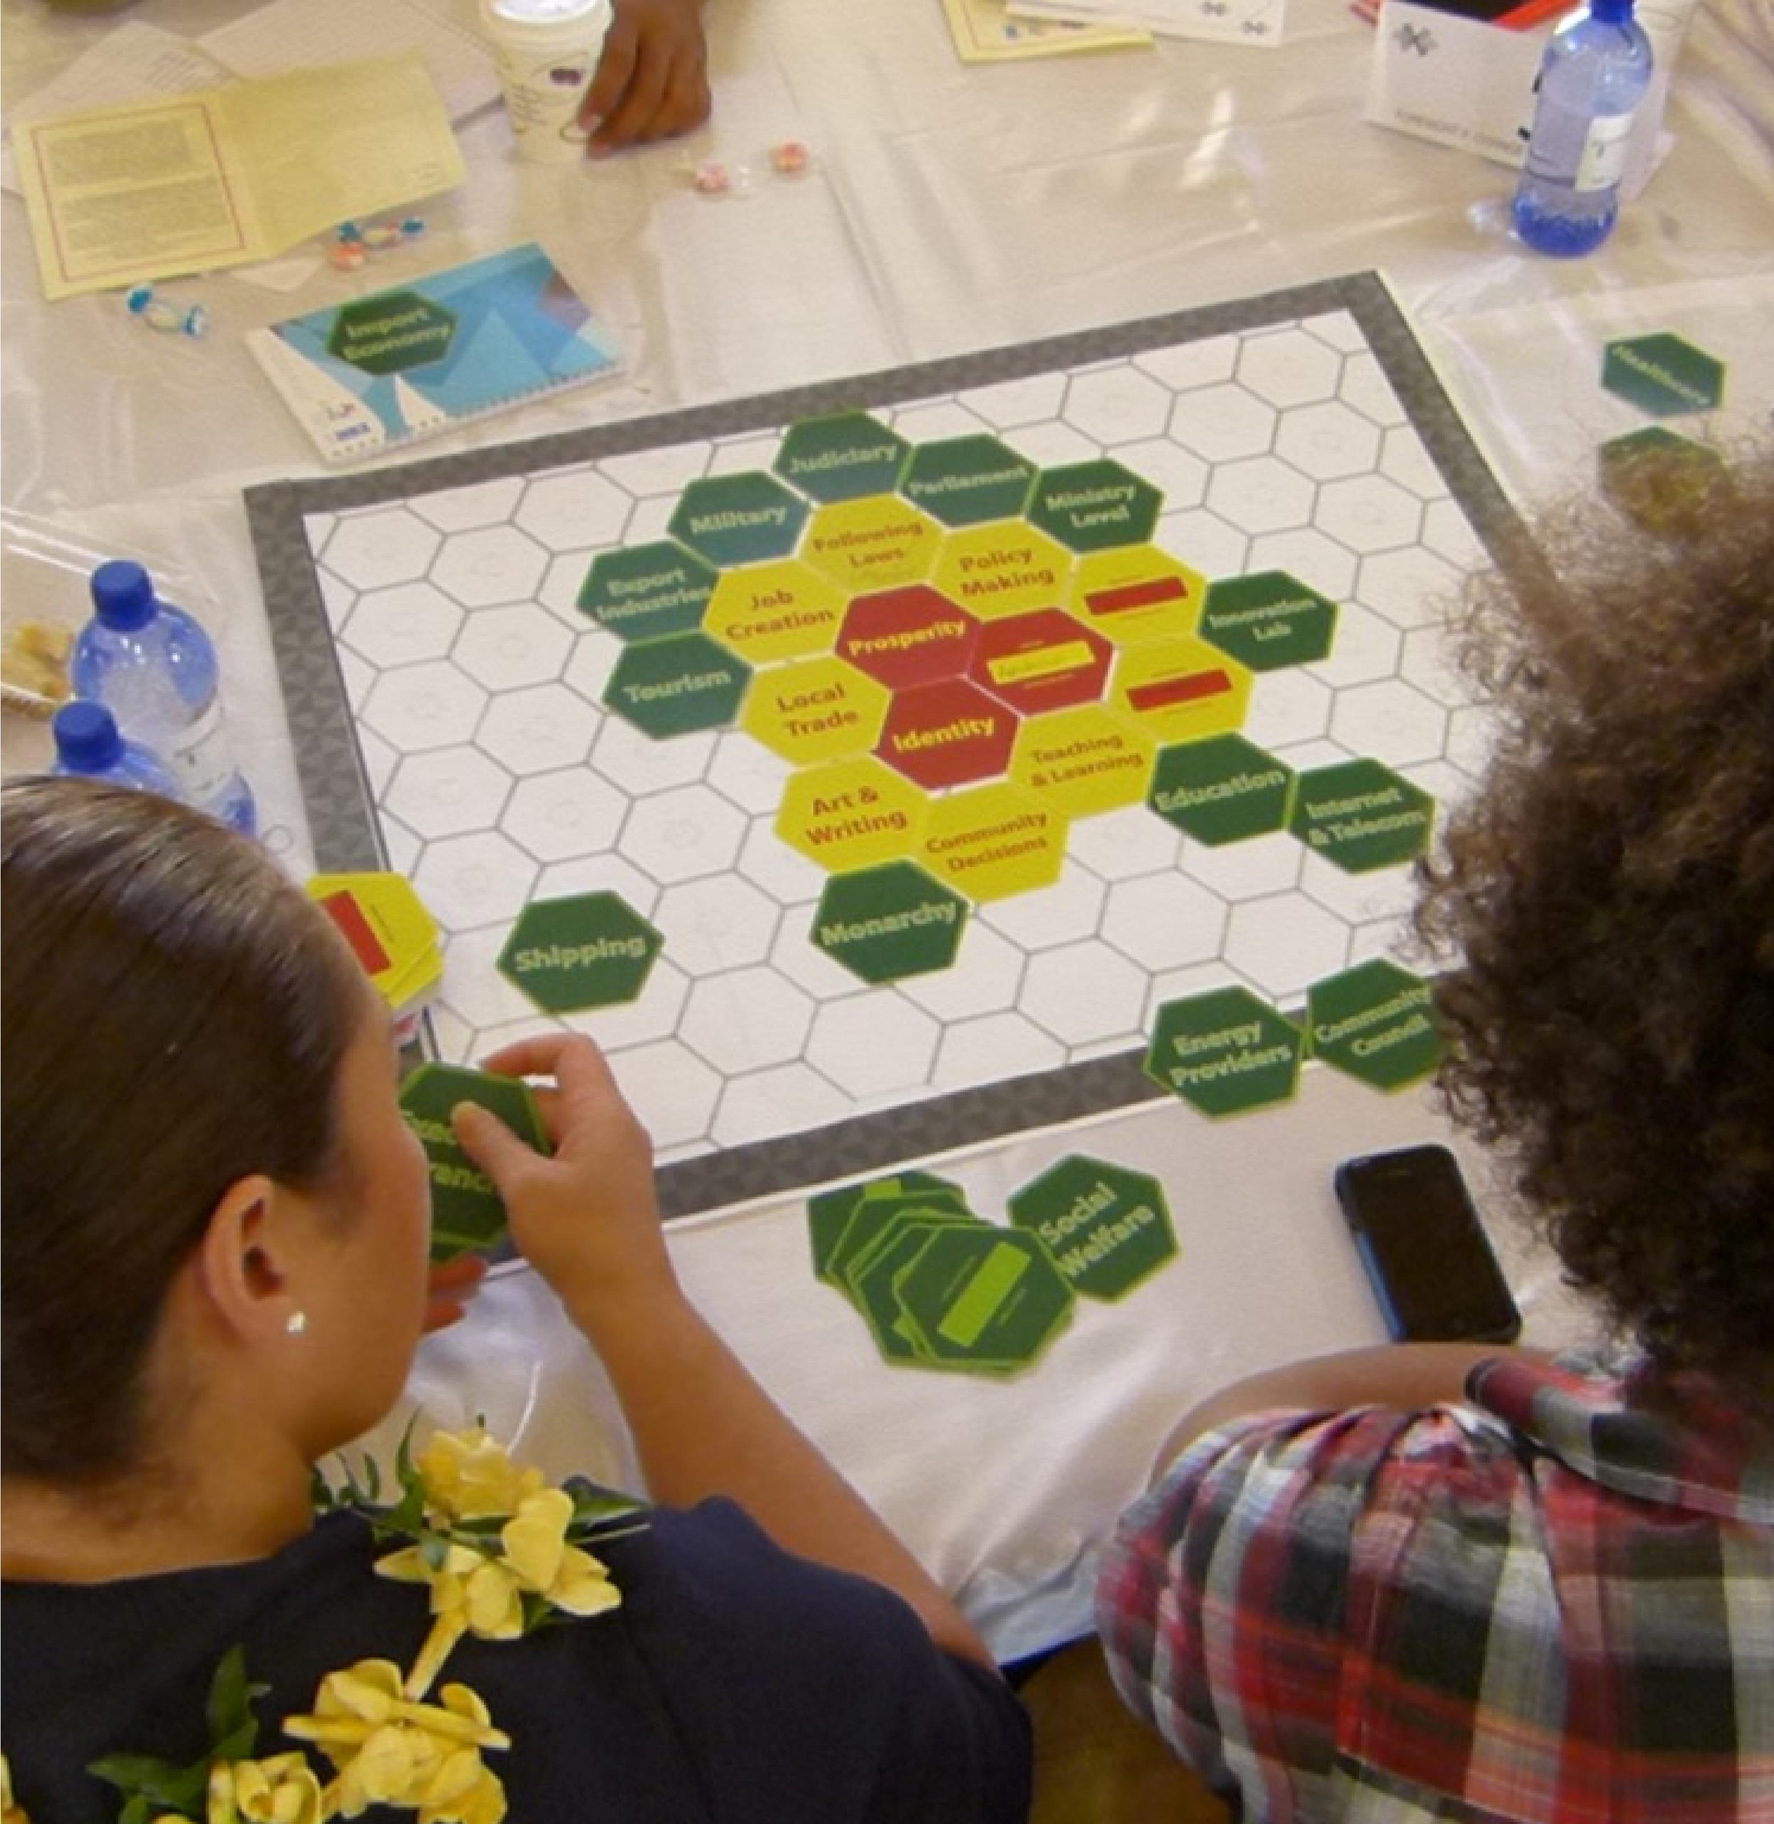
Expert Roster
In Tonga, participants explore alternative futures with a focus on climate change at a UNDP foresight workshop in August 2014.

Partners
The Innovation Facility is funded with the generous support from the Government of Denmark.
In 2014 we partnered with a variety of actors across the globe, a selection of which are represented here.
Governments, International Organisations and International Partners
Asian Cities Climate Change Resilience Network
AusAid (now DFAT)
British Council Sri Lanka
CAN International
Devex
Earth Institute
East-West Center Chicago
Emerson College Engagement Lab
European Union
FutureGov
Futurescaper
Hawaii Research Center for Futures Studies
Institute for Future
MindLab
Nesta
Transparency International
USAID
World Bank
World Economic Forum’s Global Shapers Colombo Hub
World Vision
Private Sector Partners and Local Partners
Baidu
Bangladesh Scouts
Cognitive Edge
Copenhagen Economics
Copenhagen Institute for Futures Studies
Digicel
DigitalizujMe
FabLab Barcelona
FabLab Egypt
Haitian University of Informatics (ESIH) International Institute for Sustainable Development mobimedia MTN Swaziland mysociety.org Rwanda Governance Board
SURTAB
Tilt design
Tshwane Innovation hub
Voto Mobile
UN Partners
FAO
International Telecommunications Union (ITU)
UN Global Pulse
UN Women
UNFCCC
UNFPA
UNFPA
UN-Habitat
UNICEF
Universal Postal Union (UPU)
WHO

2014 ALLOCATIONS AND EXPENDITURE BY REGION
UNDP  Region | Final  alloca0on  adjusted | Expenditure | Unspent | Delivery  rate
Africa | $922,000 | $784,754 | $137,246 | 85.11%
Asia  and  Pacific | $472,500 | $461,411 | $11,089 | 97.65%
Global  (UNDP  funded) | $500,000 | $462,184 | $37,816 | 92.44%
Global  (Denmark  funded) | $457,250 | $409,689 | $47,561 | 89.60%
Arab  States | $298,125 | $324,852 | -­‐$26,727 | 108.96%
LaLn  America  and  Caribbean | $274,500 | $340,312 | -­‐$65,812 | 123.97%
Europe  and  CIS | $275,625 | $308,338 | -­‐$32,713 | 111.68%
TOTAL | $3,200,000 | $3,091,540 | $108,460 | 96.61%
“To contribute to sustainable and equitable development, the UN system must continue to invest in innovation in its programming and in its ways of working. New partnerships must be built. We must continually improve our processes to become more agile. We must be calculated risk-takers. We should openly share what works and what doesn’t.”

Helen Clark UNDP Administrator

GLOBAL PORTFOLIO
Recipient/Implemen0ng  office | Proposal
InnovaLon  Facility | Global  knowledge  campaign  ShiW  Week  of  AcLon
InnovaLon  Facility;  Singapore  Centre;  CO  Armenia  and  fYR  Macedonia | Foresight  for  AdapLve  Leadership,  Inclusive  Futures  and  Resilience
UNDP  HIV,  Health  and  Development  Group;  Global  Fund  to  Fight  AIDS,  Tuberculosis  and  Malaria,  Geneva | InnovaLve  Results  CommunicaLon  for  Key  Affected  PopulaLons
InnovaLon  Facility;  Asia-­‐Pacific  Regional  Centre | Urban  InnovaLon
UN  Procurement  Office,  Copenhagen | Green  Procurement  Index  for  the  Health  Sector
UN  Millennium  Campaign | MY  World  /  CiLzen  Voice  and  Empowerment
UN  Global  Pulse  Lab  Jakarta | Public  policy  innovaLon  through  data
UNDP  Bureau  of  Management | Improving  UN  Vehicle  Fleet  Management
In addition to investment in specific initiatives, the UNDP Innovation Facility also strategically invests in advocacy, partnerships and communications - bringing in cutting-edge experts to accelerate our work.

AFRICA
Recipient/Implemen0ng  office | Proposal
CO  Burundi | Quick  and  cheap  energy  supply  to  IDP  communiLes
CO  Côte  d’Ivoire | Placing  the  discussion  of  gender-­‐sensiLve  policing  services  on  the  parliamentarian  and  public  agenda
CO  DRC | NarraLve  capture  about  stabilisaLon  in  South  and  North  Kivu  Provinces
CO  MauriLus | Build  a  more  resilient  society  through  innovaLve  educaLon  tools  promoLng  the  culture  of  prevenLon
CO  MauriLus | RecommendaLons  for  selng  up  of  a  Mobile  Technology  Plamorm  to  improve  outreach  of  marginalised  households
CO  Rwanda | Public  Service  Strategic  Foresight
CO  São  Tomé  Principe | Monitoring  transformaLve  impact  on  development  programmes
CO  Senegal | PromoLng  social  entrepreneurship  through  the  local  producLon  of  solar  equipment
CO  Swaziland | Establishment  of  a  Youth  InnovaLve  Hub  for  inclusive  development
CO  Zimbabwe | Towards  an  ICT4D  Policy  and  PracLce  Plamorm:  A  CollaboraLve  Public-­‐Private  Partnership  (PPP)  Model  Seeking  to  Leverage  ICTs  as  Driver  for  Economic  Development  in  Zimbabwe
Regional  Bureau  for  Africa | One  Click  Away
Regional  Bureau  for  Africa | Ebola  response
Recipient/Implemen0ng  office | Proposal
CO  Egypt | Smart  CiLzen  for  an  InnovaLve  Future
Sub-­‐Regional  Response  Facility  for  Syria | InnovaLon  in  the  Resilience-­‐Based  Development  Response  to  the  Syria  Crisis
CO  Sudan | InnovaLon  Nucleus  in  Sudan
ARAB STATES Continued.

ASIA PACIFIC
Recipient/Implemen0ng  office | Proposal
CO  Bangladesh | FiWeen  Million  Stuck  in  Traffic
CO  Bangladesh | Crowd-­‐sourcing  flood  warning
CO  Bhutan | Youth  employment  &  games
CO  Bhutan | “Virtual  Zomdu”:  Bringing  Parliament  to  people
CO  China | The  Future  is  Made  in  China
CO  Indonesia | Advancing  OperaLons  Business  Processes  -­‐  One  click  -­‐  One  Gate  Service  System  for  Direct  Project  Cost  Recovery  &  other  processes
CO  Indonesia | Post  Disaster  Needs  Assessment  Data  CollecLon  Mobile  App
CO  Malaysia | Vehicle  number  plates  (vanity  plates)  for  Tiger  conservaLon
CO  Maldives | Make  my  island!
CO  Mongolia | Turning  garbage  to  gold  in  urban  outskirts  of  Mongolia:  Solid  waste  management
CO  Nepal | Using  Social  Media  to  Combat  Gender  Stereotypes  and  Gender-­‐based  Violence
CO  Pakistan | Monitoring  and  EvaluaLon  Strategic  InformaLon  System
CO  Papua  New  Guinea | Phones  against  corrupLon
CO  Sri  Lanka | PromoLng  acLve  parLcipaLon  and  engagement  of  youth  in  policy  making  through  interacLve  web  portal  plamorm  using  NHDR  as  an  advocacy  tool
CO  Thailand | An  IncenLve  Scheme  for  PromoLng  Sustainable  Livelihood  of  Smallholders  in  an  Upper  Watershed  of  Northern  Thailand
CO  Vietnam | Using  innovaLve  techniques  for  public  legal  literacy  outreach  of  law  universiLes
Continued.
Recipient/Implemen0ng  office |  | Proposal
CO  Armenia | Social  InnovaLon  Lab  (including  HuriLab)
CO  Macedonia | Social  InnovaLon  Lab
CO  Moldova | Social  InnovaLon  Lab
CO  Montenegro | Open  Ideas  for  Montenegro
EUROPE AND THE COMMONWEALTH OF INDEPENDENT STATES (CIS) Continued.
Portfolio Snapshot by Region
LATIN AMERICA AND THE CARIBBEAN Continued.
Recipient/Implemen0ng  office | Proposal
CO  Barbados  and  OrganisaLon  of  Easter  Caribbean  States  (OECS) | SocialInnov4Change  –  Engaging  Caribbean  in  Social  InnovaLons  for  posiLve  Social  Change
CO  Ecuador | ApplicaLon  of  technological  innovaLon  in  micro-­‐enterprise  development  in  the  Metropolitan  District  Municipality  of  Quito
CO  El  Salvador | Public  value:  ciLzen  voice  and  efficient  public  services
CO  Guatemala | Reducing  vulnerabiliLes  by  increasing  access  to  water  and  green  energy  for  producLve  uses
CO  HaiL | Mobile  InnovaLon  Lab:  From  ideas  to  business
CO  Nicaragua | Energy  efficient  tradiLonal  foods

Initiatives Funded by UNDP’s
Innovation Facility

GLOBAL INITIATIVES
Amplifying Citizen Voice / My Green World
This initiative provided a direct channel for citizen participation in UN decisions that affect their daily lives it created a new body of ‘open source’ data from recipients of aid and services to national and global level decision makers, aiding transparency and accountability around these issues. The team convened policy experts, UN agencies and CSOs to design questions for citizens that would be useful for climate negotiations, tested them via SMS Poll with over 100,000 youth in Nigeria. Shaped by 12,000 responses, they built an online consultation platform which was presented during COP20 in Lima to over 1,000 CSOs and youth. Some lessons learned include the importance of consulting with policy teams and decision makers to ensure that the data collected is relevant and timely to the decision making process; keeping the data set ‘open source’ and not hard coded to enable access to it by the broadest range of data visualisation partners, from academics to civil society; and avoiding technocratic language while keeping questions concise, compelling and contextual. The lessons learned from the prototyping and incountry testing will be scaled to build a model for crowd-sourced solutions to the SDGs as well as continued perceptions based engagement.
Urban Innovation
In October 2014, UNDP together with USAID, UN-Habitat and UN Global Pulse hosted the Asia Urban Futures Workshop to bring together the science and technology sectors, the development community and progressive city planners in a novel way to discuss the rising challenges and opportunities facing Asia as the result of rapid urbanisation and climate change. Together with the Asian Cities Climate Change Resilience Network, the workshop organisers launched an Urban Resilience Competition to identify new and innovative approaches to building urban resilience particularly through broad partnerships that contribute to inclusive and pro-poor actions.
Reporting for Key Affected Populations
This initiative, supported through the UNDP Global Fund, develops innovative ways of communicating HIV results or issues among Key Affected Populations (youth, sex workers and people living with HIV), with a focus on sub-Saharan Africa. UNDP Zimbabwe developed pilot projects with three civil society groups with the aim of using innovative technology, such as new and existing social media platforms, as tools for communications and advocacy on a wide range of health and sexuality issues. The three projects aimed to improve knowledge of and access to service provision, to discuss any challenges and ways of overcoming these, and to support linkages to prevention and care.
The projects focused on improving central communication tools and setting up related social networking forums. Following the initial development of the central websites, all groups held workshops to discuss ways of communicating through social media. They further prototyped and designed these innovative communication methods through constant monitoring and feedback from end-users. They found in this context, the use of Facebook to have more engagement impact than Twitter where the restricted number of characters presented a limitation to participants fully expressing their thoughts. Increased social engagement was spurred by the creation of videos to be used as outreach and advocacy.
Green Procurement Index for the Health Sector
Continued. This joint UNDP-UNFPA initiative aims to improve the transparency of procurement in the health sector with regard to its environmental impact, and encourage UN agencies and their suppliers and manufacturers to produce, procure and
supply goods in a more environmentally friendly manner. After conducting a comprehensive analysis to understand which key products, procured across UN procurement departments could be enhanced and produced in a more environmentally friendly way, a roadmap was created on how to develop a Green Procurement Index for the Health Sector. A number of experts from the private and public sector, as well as UN procurement officers as the ‘end-users’, were engaged as a Resource Team to provide valuable feedback to improve the roadmap. Engaging multiple stakeholder’s in the early phases of the project (which involved co-designing and collaborative sharing and learning processes) was crucial in ensuring that valuable perspectives on the first draft of the project roadmap are taken into consideration and integrated in the future phases of the project.
Improving UN Vehicle Fleet Management
All UN agencies have vehicle fleets that are often managed individually which lead to resources sitting idle in UN locations around the world, contributing to a range of associated issues such as higher costs, sustainability issues and environmental degradation. UNDP studied the use of smart technology to pool vehicles fleets which can lead to better resource allocation and effectiveness, therefore addressing related issues and creating a more sustainable UN. Together with UNFPA and UNICEF, UNDP has developed a set of criteria to select countries and locations to approach for a pilot study.

AFRICA Burundi
Quick and Cheap Energy Supply to IDP Communities
In Burundi, electricity production is insufficient to meet demand, and less than 5% of the population has electricity. 95% of Burundi’s energy comes from firewood, creating a demand which exceeds domestic supply - leading to significant deforestation and high costs. During the SHIFT Week of Innovation Action, UNDP Burundi consolidated experiences in renewable energy to launch a competition to identify winning solutions in renewable energy to provide rural communities in Burundi new green alternative energy solutions that are socially viable, technically feasible, locally available and easy to implement. Over 50 participants came together including development and environment experts, government officials, an external expert in renewable energy competitions, and UNDP colleagues from Country Offices in Burundi, Bosnia and Herzegovina, and Cameroon. UNDP Burundi also participated in the Innovation Forum in Togo where 18 people submitted 6 ideas for the energy contest workshop.

Democratic Republic of Congo (DRC)
Narrative Capture about stabalization in North and South Kivu Provinces
Monitoring of results or more specifically changes on the ground, in communities where UNDP works, can be complicated as it requires special and periodic measurement. The initiative expanded a pilot project, initiated in 2013, which uses a narrative based methodology focused on people’s stories rather than traditional opinion surveys This methodology allows the expression of a larger variety of possible responses and promotes both qualitative and quantitative data collection, analysis, comparison and visualisation. With more than 340 stories collected during the
Continued. pilot in the province of South Kivu, UNDP DRC has been collecting more stories and expanding geographically to the
North Kivu province. The collections of stories are currently being analysed to gain insights into citizen attitudes on local government entities as well as their top priorities. Over time, this will allow monitoring of the change in patterns and stories that can be translated into actionable decisions and initiatives to make programmes in the area more effective.

Mauritius
Build a More Resilient Society through Innovative Education Tools Promoting the Culture of Prevention
In March 2013 Port-Louis was hit by fatal flash floods. This event precipitated the need to develop and adopt a proper disaster management system based on prevention and preparedness. As part of an ongoing effort UNDP Mauritius in partnership with the National Disaster Risk Reduction and Management Centre has been working on building a more resilient society through innovative education tools. The target is to instil a culture of prevention and infuse simple and key safety messages into communities through youth who have the potential to become influential drivers of prevention in their communities. The initiative involves activities such as gamification and competitions to maximise the involvement and interest of students. For example, a design contest encouraged students to reflect on the best way to convey safety messages promoting risk prevention. A hackathon with university students has been postponed to 2015. A good lesson learned is that even though we like to see quick wins and short-term delivery to fuel momentum, having enough time to plan activities is important to ensure that key activities materialise at key moments to achieve the best possible results.

Mauritius
Recommendations for Setting up a Mobile Technology Platform to Improve Outreach of Marginalized Households
Recent official data shows that while extreme disparities in access to fixed telephone, computer and internet exist between sub-regions, mobile phones are common cross-regionally. This makes mobile telephony an attractive solution to expanding access of social assistance to the most excluded. UNDP Mauritius assessed the present situation to produce a report to the Government of Mauritius, containing concrete recommendations on (i) the most suitable type of mobile platform to be set up to reach the most excluded households and (ii) the software requirement specifications on how to link the platform with the current social assistance system/database, (iii) the functional overview and technical architecture of the platform, and (iv) the most suitable types of SMS (manual, mass, and automated). This first phase has the potential to lay the foundation for future partnerships between UNDP and the Government on social assistance through mobile technology.

Rwanda
Shaping the Future of Rwanda through Public Service Strategic Foresight
A knowledge sharing and prototyping workshop, Rwanda foresightXchange, was held in October 2014 to address the issue of how to best develop capacities in public service, strategic planning and risk management. Attended by over 50 senior government officials, the decision-makers gathered to discuss how to incorporate “Foresight” in Rwanda’s existing planning processes. The workshop covered three main topics – the future of urbanisation in Rwanda; the
Continued. future of rural sector development; and large scale public investment projects. UNDP Rwanda is working with the
Ministry of Planning and the Rwanda Governance Board to ensure foresight will be applied as an approach in the government planning processes at the central and decentralised levels, and is exploring the implementation of a coordination mechanism for government ministries and programmes fashioned around the “Whole of Government Approach". The choice of topics turned out to be ambitious within the given timeframe and it is therefore suggested to conduct follow-up events with less emphasis on the process and more on the production of substantive scenarios on urbanisation and rural development.

Senegal
Promoting Social Entrepreneurship through the Local Production of Solar Equipment
The development of the renewable energy sector is severely limited in Senegal by the amount of initial investment required and the lack of industrial production units at the national level. This initiative aims to promote social entrepreneurship in Senegal by training women in the production, installation and marketing of solar equipment. A factory unit was set up and three innovative prototypes (solar street light, solar kit and mobile solar generator hydraulic pump) were designed by 20 women who went through the training programme. The training modules on entrepreneurship and construction of business plans are in progress. UNDP monitored field activities through four field missions which enabled an in situ exchange with all stakeholders to agree on their respective expectations, initiative results and outlook.

Swaziland
Establishment of a Youth Innovation Hub for Inclusive Development
With the country’s youth unemployment at over 40%, young, innovative developers have limited business
management and market training. No appropriate mechanisms have been established to facilitate the registration and coordination of young developers. UNDP Swaziland has established an association for innovators with the objective of promoting innovation, entrepreneurship and technology to produce responsive products that improve access to public and private services. It further provides a supportive environment and platform for local innovators to network and mentor as well as share skills, knowledge and experiences. The Innovators Association of Swaziland (IAS), now with over 160 members, advocates for the needs of innovators in the area of law and policy reform; recognition of local talent; access to local contracts; access to financial assistance; and markets; and job creation. In November 2014, IAS hosted its first conference, themed “Transforming Lives through Innovation,” with 230 attendees who discussed how innovation can transform the lives of Swazis as well as improve the country’s economy.

Regional Africa
One Click Away
UNDP strives to increase the accuracy, depth, and scope of the data it collects for the purpose of enhancing situation analyses, informing programming, strengthening evaluations, improving decision-making, and showcasing the work of UNDP. This initiative aims to strengthen UNDP’s ability to make evidence-based programming and policy decisions at the country, regional, and HQ-level through providing audio-video equipment and Geospatial Positioning System
Continued. (GPS) equipment to three UNDP Country Offices (Tanzania, Burundi, and South Africa); and the training necessary to
use this equipment for qualitative and geospatial data collection purposes. To demonstrate the usefulness of this technology to the Country Offices (CO), the initiative collected qualitative data from key expert interviews for the UNDP Global Study on Legal Aid. At the end of the mission, each CO was in a position to use the donated equipment for its own country-level purposes - creating videos and maps to strengthen data analyses and results.

ASIA-PACIFIC Bangladesh
Fifteen Million Stuck in Traffic
Traffic congestion is a huge issue in Dhaka where an unreliable public transportation system is pushing more people towards the use of private transport. In order to better understand the reasons and motivations behind people’s decision to prefer private cars over public transport, UNDP Bangladesh worked with a focus group, who usually travel by private car, to try out bus rides for a week. Their experience revealed that the top reason for not using public transportation is unreliability of the service, mainly concerning punctuality and travel time. UNDP is running an awareness raising campaign together with the Ministry of Roads and Transportation and public transport operators to change their perceptions and 'move the people' towards the public transportation system. The campaign is currently being rolled out through various media channels, while solutions are being tested and sought for running a quality bus service within the current traffic situation. The next stages of the project will entail strengthened efforts to create public transportation options which meet expectations for safety, convenience, comfort, timelines and cost for those who would otherwise use a private vehicle.

Bangladesh
Crowd-sourcing Flood Warnings
The existing flood forecasting system in Bangladesh does not alway deliver timely and comprehensible messages directly to flood prone communities — almost 20% of the population — that enable them to respond to the flood warning. To quickly communicate the arrival of flash floods in the absence of a formal early warning system UNDP Bangladesh used mobile phones – now ubiquitous in Bangladesh – to crowdsource flash-flood warnings from vulnerable people. Affected upstream communities living by river banks could convey messages that would be instantly shared with communities living downstream. This would give the communities lead time of between three to 36 hours — a minimum requisite for saving lives and livelihoods of vulnerable communities. The initiative is now being prototyped in two communities where awareness campaigns with 200 locals were held. At the campaign the early warning system using crowd sourcing was explained and demonstrated by acting out the procedure.
Additionally three committees were formed, with local members from a diverse range of stakeholders including the Bangladesh Scouts, to create a network to monitor the effectiveness of the warning system.

Bhutan
Continued. Gamification for Youth Unemployment
Though almost half the population in Bhutan are under the age of 25, youth are the largest unemployed demographic. In order to help young people in Bhutan participate in the creation of solutions for this issue, UNDP Bhutan in partnership with the Ministry of Labour of Bhutan and Emerson College (USA), launched the online gaming project Youth@Work. Played online, or through SMS, game participants answer questions and complete exercises designed to build empathy between different members of society, raise awareness of youth employment issues, and instil a sense of personal responsibility for various aspects of Bhutan’s youth unemployment issue. Throughout the process, participants gain the opportunity to express their opinions about what is missing from the system and deliberate on the best solutions. Participants can also promote ideas for new projects, with the most popular proposals being recognised by the organisers and awarded funding at the conclusion of the game. Before the game was launched, UNDP Bhutan conducted three workshops involving youth, parents, teachers, the private sector and government officials to discuss the content of the game. There are not many forums where youth can engage and provide feedback to the policy makers on unemployment issues. The game, now used by over 2,000 people, helps to address this gap by providing a forum for a frank exchange of opinions using play, and building empathy and understanding between participants and decision -makers. UNDP Bhutan and the Ministry of Labour will incorporate the inputs and ideas gained into long-term strategic plans for the country.

Bhutan
“Virtual Zomdu”: Bringing Parliament to the People
In Bhutan, where almost 70% of the population live in rural areas, many parliamentarians take over a week to visit remote areas of their constituencies due to the mountainous terrain and limited road access. In Bhutan, ‘Zomdu’ is a meeting among community residents. However, through “Virtual Zomdu” UNDP Bhutan is utilising and expanding the existing community centres across the country with Internet connectivity to enable citizens across Bhutan to meet with their parliamentarians virtually and frequently via videoconferencing platforms. Through initial trials, the advantages for the parliamentarians were shown in terms of the time and costs saved for traveling. The trials also showed increased engagement from villagers, which was a positive indication that this form of regular communications between the constituents and parliamentarians may contribute to enhanced accountability and transparency of the government. These results garnered much interest and the project is in the process of being expanded and tested in 47 constituencies across Bhutan.

Indonesia
Post-Disaster Needs Assessment Data Collection Mobile App
The tools currently available in Indonesia to collect information after disasters do not allow for immediate analysis. When UNDP Indonesia and the National Disaster Management Agency (BNPB) looked for the most reliable
communication platform to circulate real-time (post-disaster) data, mobile phone applications became the top choice, as eight out of ten Indonesians have access to cell phones. Post-disaster data collection in Indonesia involves a variety of actors who aim to gather and analyse data in the most efficient and timely manner. Thanks to the mobile phone application linked directly to the BNPB data server, personnel compiling lists of infrastructure destruction
and casualties can now seamlessly upload in real-time data straight from the disaster-hit areas with the click of a button. The data will be sent for data analysis and to those who are charged with taking immediate action to help the
Continued. affected population.

Indonesia
Advancing Operations Business Processes - One Gate Service System
The lack of an integrated corporate tool to record requests from clients, track progress, send automated bills and receive online feedback has resulted in labour-intensive and time-consuming transactions and business processes for Country Offices. UNDP Indonesia’s operations team has been developing a new integrated business solution system to ensure timely and accurate cost recovery from the services provided to their internal and external clients. The tool, created in December 2014, enables the operations team to receive online requests, manage workload among the team, notify clients on progress, provide automated billing links in the ATLAS system and manage feedback for improvement. An initial analysis during the pilot phase highlighted the improved timeliness of billing submissions, reduced risk of losses due to missed charges and overall increased productivity for the teams involved in testing. Streamlining these business processes and making them more interconnected will benefit UNDP senior management, Country Offices in the Region and corporate bureaus.

Malaysia
Vehicle Number Plates (Vanity Plates) for Tiger Conservation
‘The Central Forest Spine’ in Malaysia is a wildlife sanctuary across five million hectares that harbours an incredible array of plant and animal species including the endangered Malayan tiger. It is also the source of essential water for over 28 million people including the inhabitants of Singapore. In efforts to finance a government devised National Conservation Trust Fund, UNDP Malaysia looked to local sources of funding that involved Malaysian citizens in conservation efforts. This helps to ensure long term sustainability and create national ownership. UNDP Malaysia created specially designed vehicle license plates for which people pay an extra amount that goes to wildlife conservation. Even if only 1% of Malaysia’s 20 million vehicles bear the tiger plate, it could generate US$6 million at US $30 per number plate per year. If successful this scheme can be extended to vehicles in Singapore which also depend on the ‘spine’ for water. This will furthermore test an innovative bilateral initiative which other countries in Asia and beyond could follow.

Mongolia
Turning Garbage into Gold in the Urban Outskirts of Mongolia: Solid Waste Management
UNDP Mongolia is working with low-income migrant communities to set up a system for recyclable waste collection in their neighbourhood to produce recycled goods and market those products. At first, to test out the viability of this idea, only a few products with high potential demand are being produced. A local NGO engaged in business incubation is working with UNDP Mongolia to facilitate workshops and trainings with the end-users as well as market the products (via Facebook, for example). Sample products include brooms for street produced from the plastic of recycled bottles. The crowdsourcing method was applied to generate new ideas and designs of recycled products. Once the prototyping is proven successful, the initiative can be replicated in all major cities and generate income for the unemployed migrant population. Marketplaces, exhibitions, press
conferences, TV footage and, social media were used to advocate and market the products and seek partnership opportunities with local companies. A number of national food producers have become raw material suppliers and
Continued. expressed their interest to expand the collaboration with UNDP Mongolia on follow-up interventions.

Nepal
Using Social Media to Combat Gender Stereotypes and Gender-based Violence
According to a report on gender-based violence released by the Government of Nepal in 2012, nearly half of all Nepali women reported experiencing violence. A recent UNDP study revealed that the social norms and expectations concerning masculinity and femininity critically shape socio-cultural and legal institutions. Vis-à-vis the study and building on its findings, UNDP Nepal has created a campaign targeting young people through a series of animated videos, each focused on a particular form of violence such as harassment, domestic violence, political violence and sexual violence. They depict situations where traditional gender roles have been inverted, in order to make young people question "how abnormal the normal is" and to change their behaviour. These pieces were developed into games and launched on Facebook as part of the social media campaign to leverage youth-friendly tools to induce social change. Physical outreach to students is ongoing and aims to engage at least 500 young people at the prototyping stage. The campaign is sparking debates on Facebook with positive feedbacks from those who have been reached. Pakistan
Monitoring and Evaluation Strategic Information System
In UNDP Pakistan, there was an emerging consensus on the negative impact on programming due to the lack of realtime monitoring and evaluation data. This unavailability or lack of monitoring and evaluation data not only negatively impacted the reporting on results and progress within UNDP and to donor organisations but also impeded the tracking of progress and impact. UNDP Pakistan is improving on the current results-based management platform by developing an information system capable of generating strategic information to help programmes and projects track progress and demonstrate the impact of a given project, programme, or policy in a timely fashion. This monitoring and evaluation strategic information system will also be linked with UNDP’s Corporate systems (Atlas and the Corporate Strategic Planning System) which will reduce double data entry and further facilitate all the projects to use one UNDP Monitoring and Evaluation system instead of relying on Project-specific legacy information management systems. The system is in the final stages of development and a pilot test run has been successfully launched in Pakistan. The system provides live and dynamic project results and resource dashboards with interactive maps showing intervention areas and progress made for decision-makers at UNDP and donor organisations.

Sri Lanka
Youth Engagement in Policymaking and Implementation
According to the 2013 National Youth Survey 88% of Sri Lanka’s youth stated that they are interested in current affairs and socio-economic developments taking place around them, but the very same individuals are disengaged and uninvolved. The 2014 National Human Development Report has been leveraged to foster a national debate on some of the issues faced by the youth. UNDP Sri Lanka has provided young people with opportunities to exchange ideas via
Facebook campaigns, thus improving youth participation in the political and civic dimensions. These discussions
Continued. helped build a platform for youth engagement, which led to an offline meet-up titled “Civic and political youth
participation and the use of technology with a view of #2030NOW” The Social Good Summit addressing many of these issues both on-line and off-line. Fulfilling a request made by youth UNDP Sri Lanka started ‘UNLOCKED’ — a youth and development themed blog.

Thailand
Sustainable Maize
As one of the world’s top chicken producers, the amount of grain needed to produce chicken-feed have caused more than 5 million acres of agricultural and forest land to be cleared for maize farming. The current farming practices of maize have caused several problems, such as — soil deterioration and contaminated water sources from excessive use of chemical fertilisers and pesticides; flooding and landslides resulting in road accidents and crop damage from widespread clearing of forestlands; and a negative impact on health effects from the smoke and haze created by burning of maize residuals. UNDP Thailand brought together different actors in the farming and poultry industries as well as buyers from supermarkets and restaurants for a field meeting in northern Thailand, the largest maize producing region of the country, to generate ideas for “win-win solutions” that might alter the current farming and business practices towards a more sustainable approach. These consultations form the backbone of an incentive scheme to be developed by UNDP’s “Sustainable Maize Supply Chain” project in partnership with the Thai government starting 2015.

Viet Nam
Public Legal Literacy Outreach of Law Universities
Providing information about basic labour rights under domestic laws to marginalised citizens is a challenge in Viet Nam. This initiative combines the abilities of law students and local communities to change the face of the traditional education systems and improve public legal literacy. As a first step, UNDP partnered with a law school to send 12 students to spend a weekend with a family in a local community to listen and learn about their most pressing concerns. After the weekend, the students participated in a follow-up workshop with University faculty and private lawyers to learn about the legal issues raised during their stay and discuss how they can respond in order to return to the community and advise on these issues. By making community homesteads the “new law school”, the law students are breaking the antiquated education system and raising the capacity of the country’s justice sector to be more responsive to the needs of the local communities. The marginalised communities who may not be aware of how justice services can help improve their lives are also benefitting from the reach of future legal practitioners. Through preliminary feedback, several of the residents said they have a far better understanding of their labour rights, and will share them with neighbours.
EUROPE AND THE COMMONWEALTH INDEPENDENT STATES (CIS)

Continued. Montenegro
Open Ideas for Beautiful Montenegro
Through UNDP Montenegro’s direct engagement with the citizens of Montenegro, we learned that many public spaces remain under used, due to insufficient resources, or lack of capacities. This is particularly the case in northern Montenegro, where poverty and unemployment rates are higher. However, at the same time, we are witnessing growing tech activism by youth around issues of democracy, the "start-up" economy, arts and culture. In collaboration with the Government of Montenegro and NGO partners, UNDP Montenegro launched a social innovation competition, entitled 'Open Ideas for Beautiful Montenegro', serve as a conduit for civic activism, asking the most inspired innovators to revamp five public spaces and help fight poverty, unemployment and revive Montenegro’s cultural and historical heritage, by creating new economic value.

LATIN AMERICA AND THE CARIBBEAN
Barbados and the Organisation of Eastern Caribbean States
SocialInnov4Change – Engaging the Caribbean in Social Innovations for Positive Social Change
Youth violence has become a critical development challenge for the people of the Caribbean region. This increase in violent crime has also contributed to a growing sense of insecurity amongst the general population.
SocialInnov4Change is an initiative aimed at bringing young people together to jointly find solutions that address social problems and challenges within communities. A 72-hour innovation lab in St Kitts and Nevis brought together 25 young people to develop a solution to engage the youth on a citizen-centred approach to reducing youth crime, youth gangs and gender-based violence through design thinking methodology. This initiative partnered with local NGOs, the Department of Youth Empowerment and UN Women to amplify results. The five most innovative solutions received seed funding and are working with the Department of Youth Empowerment and other stakeholders to fine tune their plans to have their ideas implemented in the next three months.

Ecuador
Implementation of Technological Innovation for the Development of Micro-enterprises
There is a high rate of corporate mortality in micro and small enterprises linked to factors such as weak training, limited innovation and product selection; informal financial management; limitations on access to credit; and insufficient installed capacity to export their products. The traditional programs of business advice and support have not succeeded with micro and small enterprises. The initiative aimed to collect geo-referenced data via mobile devices, offering basic business services required by small and micro enterprises in pilot neighbourhoods. The initiative was incorporated as a priority action of the new municipal government to be fully implemented in the first half of 2015.

Nicaragua
Continued. Energy Efficient Traditional Foods
The production of traditional foods using wood burning ovens and stoves in the northern city of Somoto consumes about 5,000 tonnes of firewood per year, contributing to deforestation, increased carbon dioxide emissions as well as respiratory problems. In order to reduce deforestation, increase productivity, reduce production costs and improve people’s health by reducing public exposure to smoke, it is necessary to replace traditional technologies for innovative green technologies. The initiative has been designed in coordination with the Local Government of Somoto to identify needs, design technology, elaborate prototypes, implement and evaluate the initiative. As this is an important economic activity in the region, particularly for women, UNDP Nicaragua is working with the local community, businesses and municipality to replace traditional wood burning ovens with more energy efficient technology to meet the needs of the community. So far the project has worked with 31 producers and their families (an estimated 210 people), replacing over 30 traditional technologies with new ones resulting in 60% less wood consumption.

